California Employment Report for November 2024

The Center for Jobs and the Economy has released our initial analysis of the November Employment Report from the California Employment Development Department. For additional information and data about the California economy visit [www.centerforjobs.org/ca.](http://www.centerforjobs.org/ca.) Due to the upcoming holidays, we will be publishing only the current report rather than our typical initial and full versions.

**California Labor Force**

|  |  |  |  |  |  |
| --- | --- | --- | --- | --- | --- |
| **Seasonally Adjusted** | **California** |  |  | **US** |  |
|  | Nov 2024 | Change from Oct 2024 |  | Nov 2024 | Change from Oct 2024 |
| Unemployment Rate | 5.4% | 0.0 |  | 4.2% | 0.1 |
| Labor Force | 19,396,000 | -0.1% |  | 168,286,000 | -0.1% |
| Participation Rate | 62.1% | 0.0 |  | 62.5% | -0.1 |
| Employment | 18,341,000 | -0.1% |  | 161,141,000 | -0.2% |
| Unemployment | 1,055,000 | 0.9% |  | 7,145,000 | 2.3% |

|  |  |  |  |  |  |
| --- | --- | --- | --- | --- | --- |
| **Not Seasonally Adjusted** | **California** |  |  | **US** |  |
|  | Nov 2024 | Change from Nov 2023 |  | Nov 2024 | Change from Nov 2023 |
| Unemployment Rate | 5.3% | 0.4 |  | 4.0% | 0.5 |
| Labor Force | 19,337,200 | -0.3% |  | 168,164,000 | 0.1% |
| Participation Rate | 61.9% | -0.4 |  | 62.4% | -0.3 |
| Employment | 18,313,500 | -0.7% |  | 161,456,000 | -0.4% |
| Unemployment | 1,023,700 | 6.8% |  | 6,708,000 | 15.1% |

|  |  |
| --- | --- |
| **5.4%**  **CA Unemployment Rate** | California's reported unemployment rate (seasonally adjusted) was unchanged at 5.4%. The US rate edged up 0.1 point to 4.2%.  Among the states, California again had the second highest unemployment rate, behind Nevada with 5.7%. DC also had a higher rate at 5.7%. |

|  |  |
| --- | --- |
| **-19.6k**  **CA Employment** | Employment fell 19,600 (seasonally adjusted), with the total employment loss since the previous peak in May 2023 at 101,100.  US employment fell by 355,000.  California unemployment continued rising by 9,400, while US unemployment also rose, by 161,000. **California unemployment has been above 1 million every month to date in 2024, the highest levels since the pandemic period in 2021.** |

|  |  |
| --- | --- |
| **62.1%**  **CA Labor Force Participation Rate** | California labor force (seasonally adjusted) fell 10,200, while the labor force participation rate was unchanged at 62.1%. The US labor force was down 193,000, while the participation rate notched down 0.1 point to 62.5%. |

**Recovery Progress: CA Employment vs. Other States**

Compared to the pre-pandemic peak in February 2020, California’s relative ranking for employment recovery remained at 5th lowest among the states and DC.

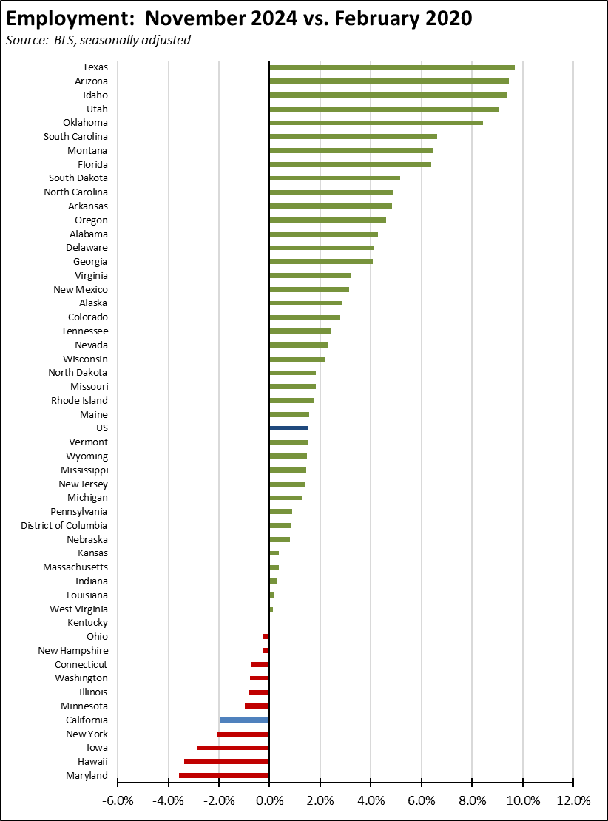

**Nonfarm Jobs**

|  |  |
| --- | --- |
| **11.1k**  **Nonfarm Jobs Change** | Nonfarm wage and salary jobs rose 11,100 in the preliminary results for November, while the October losses were revised to a gain of 9,100.  For the US as a whole, nonfarm jobs rose 227,000 as some states recovered from the prior month losses due to strikes and hurricanes.  The seasonally adjusted numbers for California showed gains in 10 industries and losses in the other 8. Increases were led by Healthcare & Social Assistance (11,400),  Administrative & Support & Waste Management & Remediation Services (2,300), and Wholesale Trade (2,300). Losses were led by Other Services (-3,300), Real Estate & Rental & Leasing (-3,200), and Construction (-2,800). |

**Hourly Wages Up 5.2%—Average Hours Edge Down**

Over the 12 months ending November 2024, average hourly wage in all private industries saw growth of 5.2%. Only a portion of these gains were offset as average weekly hours worked edged down by only 0.9%.

The results, however, varied widely by industry. Professional & Business Services saw the highest wage gains at 10.4% along with Other Services also at 10.4%. Information saw the greatest hours contraction at -5.6%.

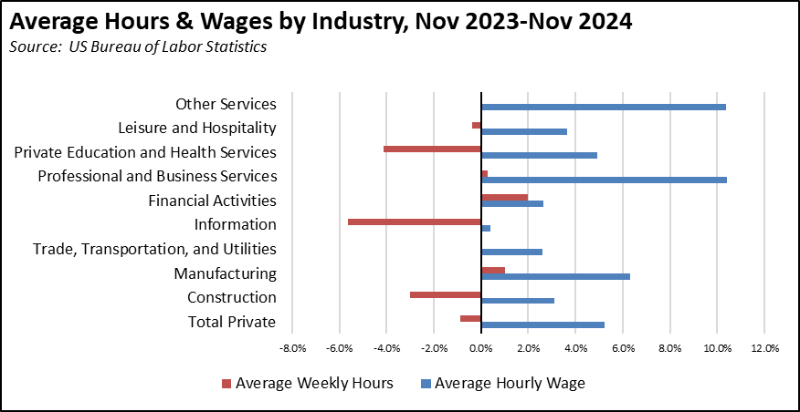

**Recovery Progress: CA Nonfarm Jobs vs. Other States**

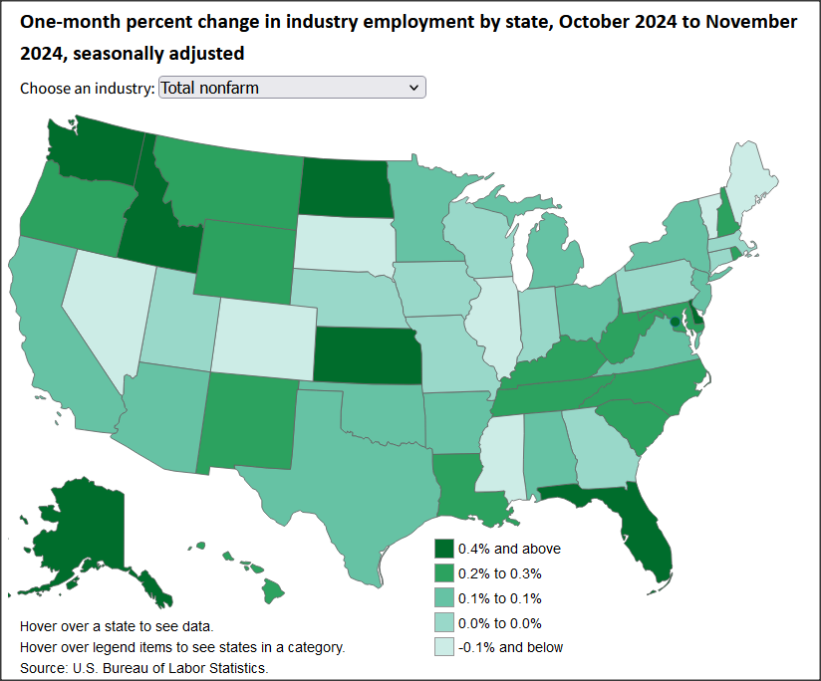

*Interactive Original:* [*https://www.bls.gov/charts/state-employment-and-unemployment/change-in-nonfarm-employment-by-state-map.htm*](https://www.bls.gov/charts/state-employment-and-unemployment/change-in-nonfarm-employment-by-state-map.htm)

California’s monthly job performance in November was the 5th highest among the states and DC. Jobs growth instead was led by Florida with 61,500, Washington with 30,900, and North Carolina with 15,000. The Texas number included some bounce-back from Hurricane Beryl. Again, these rankings reflect in part recovery from the previous month’s losses due to strikes and hurricane closures.

Compared to the pre-pandemic peak, California has now gained a net 438,900 nonfarm jobs, remaining in 3rd place just ahead of much smaller North Carolina.



Adjusted for size, California notched down to 32nd highest, still below the US average. Only 5 states and DC remain below their pre-pandemic peaks.

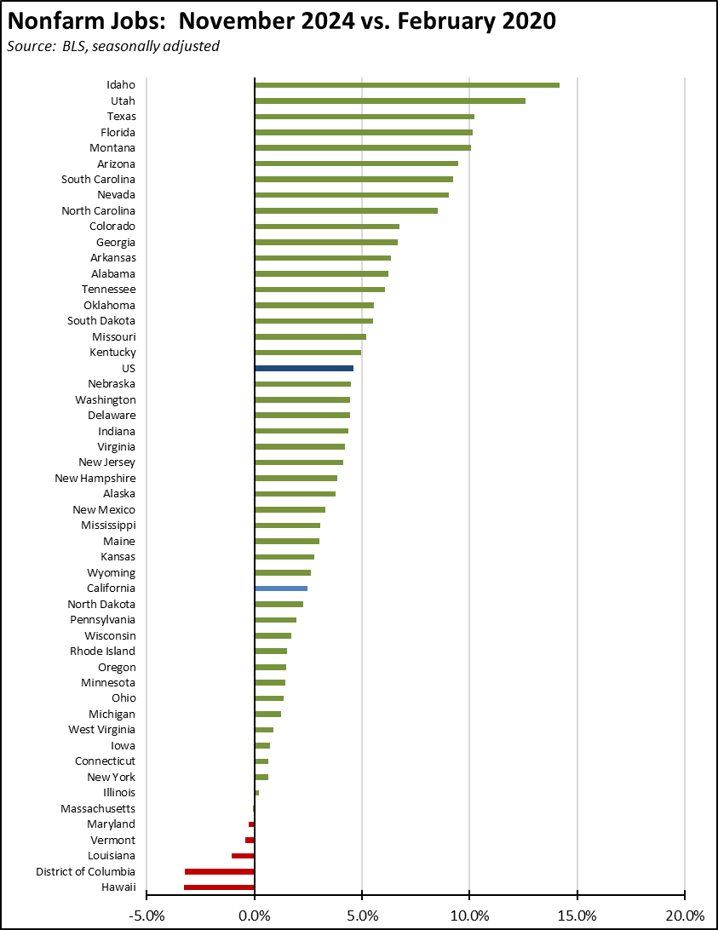

**QCEW Job Counts—2024 Q2 Results**

As we have discussed in the past, the monthly job numbers issued by EDD and BLS are estimates based on surveys and modeling. The preliminary numbers released each month are then revised in the subsequent month’s release, and all numbers are further revised each year based on the actual job counts contained in the Quarterly Census of Employment & Wages (QCEW).

The [Governor’s Office](https://www.gov.ca.gov/2024/12/11/icymi-private-sector-jobs-are-backbone-of-californias-job-growth/) recently drew on the latest 2024 Q2 QCEW numbers to make the claim that California created more than 523,000 private sector jobs between January 2022 and June 2024. This result comes solely from cherry-picking the data and taking advantage of the fact that the QCEW data reports the raw numbers for each month and is not seasonally adjusted. The data for California in fact shows high seasonal variations, with January typically the low point for each year. For example, the January 2022 private jobs number reflects a drop of 206,761 in holiday hirings from December, quickly followed by a seasonal addition of 251,288 in February as employers resumed their annual cycles. Roughly half of the Governor’s number is simply one month’s worth of seasonal fluctuations.

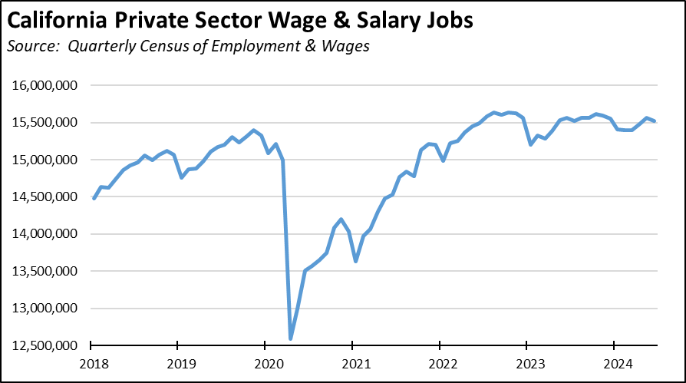

In order to make accurate comparisons, analysts typically adjust how they treat unadjusted data like the QCEW through some means such as the seasonal adjustments applied in the monthly job numbers, a moving average, or by comparing the same period (month) in different years.

Using the last method, a different but far more accurate picture emerges from the data. Comparing each month to date in 2024 with the corresponding month in 2022, total private jobs have been slowing throughout 2024, and by June showed a growth of only 31,121 over the two-year period.

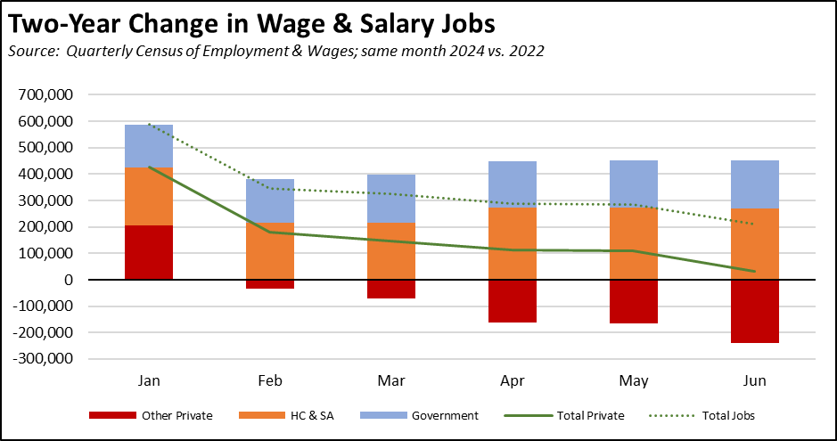

The composition of those private sector jobs is also significant. Healthcare & Social Assistance (NAICS 62)—largely as the result of government funding expansions—grew by 270,990 jobs as of June. Of these, 117,406 were in Individual & Family Services (NAICS 6241) largely composed of minimum wage, low hour In-Home Supported Services workers paid through state Medi-Cal.

In contrast, jobs in all other private sector industries fell by 239,869.

The Governor’s release was correct in stating that “Private sector jobs are [the] backbone of California’s job growth,” but the reality is that those jobs have stalled and are now in decline. Job growth instead has been coming solely from expansion of government jobs and government supported jobs in Healthcare & Social Assistance. As the essential revenue base shrinks along with the private jobs base supporting it, even that growth comes into question.

The Governor has tacitly admitted this situation through the release of his latest [jobs plan](https://www.gov.ca.gov/2024/12/16/governor-newsom-releases-new-framework-to-create-high-paying-career-pathways-with-and-without-four-year-degrees/). A more [direct version](https://ajed.assembly.ca.gov/sites/ajed.assembly.ca.gov/files/hearings/Lt.%20Gov%20Economic%20Growth%20and%20Competitiveness%20Agenda.pdf) addressing more the state-imposed constraints to private sector jobs growth instead comes from his term as Lieutenant Governor, highlighting the need for more fundamental changes including:

1. “Tackle the issues of cost and regulation by streamlining, simplifying, and aligning California’s policies to improve its reputation and business climate,” rather than the regulatory expansion that resulted by 2023 in a total of 420,434 [restrictions in state regulations](https://www.quantgov.org/), compared to 296,926 in the next highest state (New Jersey) and an average of only 132,094 in all other states;
2. expansion of manufacturing, rather than the increasing cost environment that has seen manufacturing jobs drop by 52,100 since their recent peak (seasonally adjusted) in July 2022.
3. expansion of trade opportunities, rather than the current spate of state and local restrictions raising the cost and limiting the use of the state’s ports;
4. “doubling down” on R&D, rather than last year’s action limiting the use of R&D credits and raising the cost of these activities in the state;
5. “comprehensive federal and state tax reform that creates certainty for business and eliminates disincentives to domestic investment,” rather than recent actions that increased corporate income taxes by more than $6 billion, unemployment insurance taxes by more than $2 billion and growing over the coming years, and state payroll taxes by $5 billion.

**QCEW Job Counts—Monthly Job Estimates Likely to Be Lowered**

The full counts from the QCEW have become even more important as the response rates have fallen steeply in the surveys used to produce the monthly job and labor force estimates. As discussed in the past, the QCEW results and their likely effect on the annual revisions for each state are now tracked regularly by the  [Federal Reserve Bank of Philadelphia](https://www.philadelphiafed.org/surveys-and-data/regional-economic-analysis/early-benchmark-revisions).

Factoring in the 2024 Q2 results, these early benchmark numbers based on the QCEW indicate that instead of growing by 79,800 (seasonally adjusted) between January and June, nonfarm jobs contracted by 156,400. Expected changes in nonfarm numbers for the early benchmark period are shown in the chart. Note that this number is substantially more than the preliminary revision expectations announced by US Bureau of Labor Statistics for March. Divergence between the monthly modeled estimates and the QCEW counts has grown since then.

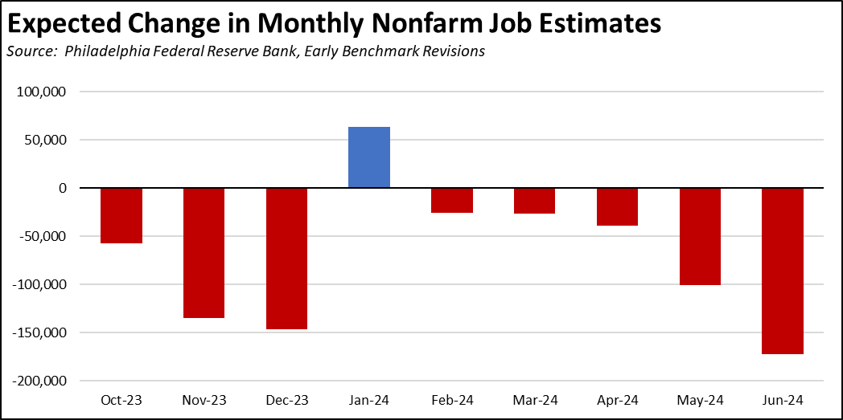

**Nonfarm Jobs by Region**

By region, job gains were concentrated in the Inland Empire, Bay Area, and Orange County. Compared to pre-pandemic levels, the interior regions and San Diego/imperial continued to show the strongest gains, while the Bay Area continued to post the largest shortfall.

|  |  |  |
| --- | --- | --- |
| **Nonfarm Jobs by Region** | | |
| *Source: EDD, seasonally adjusted* | | |
|  | | |
|  | **Change from October 2024** | **Change from February 2020** |
| Inland Empire | 3,700 | 126,100 |
| Bay Area | 3,000 | -44,600 |
| Orange County | 2,500 | 21,900 |
| Los Angeles | 0 | -31,600 |
| Central Valley | -800 | 119,300 |
| Sacramento | -900 | 60,200 |
| Central Coast | -1,400 | -8,400 |
| San Diego | -2,700 | 50,000 |

Because the data in the table is seasonally adjusted, the numbers should be considered as the total for the counties in each region rather than the regional number. This job series also is not available for all areas in California.

**Unemployment Rates by Region**

Looking at employment change over the year, the Central Valley showed the strongest gains, followed by Los Angeles moving into the plus column. Compared to the pre-pandemic period, the strongest shortfalls remain in Los Angeles and the Bay Area.

|  |  |  |
| --- | --- | --- |
| **Employment by Region** | |  |
| *Source: EDD, not seasonally adjusted* | |  |
|  |  |  |
|  | **Change from Nov 2023** | **Change from Feb 2020** |
| Central Valley | 23,100 | 58,500 |
| Los Angeles | 16,300 | -312,600 |
| Upstate California | 7,540 | -3,880 |
| Inland Empire | 3,600 | 38,900 |
| Central Sierra | 1,240 | -310 |
| Sacramento | -9,010 | 4,270 |
| San Diego/Imperial | -20,500 | -32,200 |
| Central Coast | -21,100 | -6,400 |
| Orange County | -25,900 | -65,100 |
| Bay Area | -98,200 | -238,800 |

Unemployment rates (not seasonally adjusted) remain higher most regions compared to pre-pandemic February 2020 levels.

|  |  |  |
| --- | --- | --- |
| **Unemployment Rate by Region** | | |
| *Source: EDD, not seasonally adjusted* | | |
|  | | |
|  | **Nov-24** | **Feb-20** |
| *California* | *5.3* | *4.3* |
| Orange County | 4.0 | 2.8 |
| Bay Area | 4.2 | 2.7 |
| Sacramento | 4.7 | 3.7 |
| Central Sierra | 4.8 | 4.5 |
| Inland Empire | 5.2 | 3.9 |
| San Diego/Imperial | 5.2 | 3.8 |
| Central Coast | 5.4 | 7.0 |
| Los Angeles | 5.7 | 4.3 |
| Upstate California | 5.9 | 6.3 |
| Central Valley | 7.7 | 8.4 |

**Counties with Double-Digit Unemployment**

|  |  |
| --- | --- |
| **3**  **Counties with Unemployment Above 10%** | The number of counties with an unemployment rate (not seasonally adjusted) at 10% or more edged up to 3. The unadjusted rates ranged from 3.5% in San Mateo to 19.0% in Imperial. |

**Unemployment Rate by Legislative District**

The estimated unemployment rates (not seasonally adjusted) are shown below for the highest and lowest districts. The full data and methodology are available on the Center’s website.

|  |  |  |  |  |  |  |
| --- | --- | --- | --- | --- | --- | --- |
| Lowest | CD11 Pelosi (D) | 3.6 | SD38 Blakespear (D) | 3.7 | AD23 Berman (D) | 3.2 |
|  | CD40 Kim (R) | 3.6 | SD40 Jones (R) | 3.7 | AD76 Maienschein (D) | 3.3 |
|  | CD50 Peters (D) | 3.7 | SD10 Wahab (D) | 4.2 | AD19 Ting (D) | 3.3 |
|  | CD15 Mullin (D) | 3.7 | SD34 Umberg (D) | 4.3 | AD26 Low (D) | 3.5 |
|  | CD16 Eshoo (D) | 3.7 | SD02 McGuire (D) | 4.3 | AD21 Papan (D) | 3.6 |
|  | CD47 Porter (D) | 4.0 | SD36 Nguyen (R) | 4.4 | AD72 Dixon (R) | 3.6 |
|  | CD49 Levin (D) | 4.0 | SD32 Seyarto (R) | 4.6 | AD16 Bauer-Kahan (D) | 3.7 |
|  | CD17 Khanna (D) | 4.0 | SD06 Niello (R) | 4.6 | AD12 Connolly (D) | 3.9 |
|  | CD02 Huffman (D) | 4.0 | SD30 Archuleta (D) | 4.8 | AD68 Valencia (D) | 3.9 |
|  | CD03 Kiley (R) | 4.2 | SD22 Rubio (D) | 5.0 | AD77 Boerner Horvath (D) | 3.9 |
|  |  |  |  |  |  |  |
| Highest | CD24 Carbajal (D) | 6.4 | SD08 Ashby (D) | 5.0 | AD32 Fong (R) | 6.7 |
|  | CD46 Correa (D) | 6.4 | SD24 Allen (D) | 5.3 | AD65 Gipson (D) | 6.9 |
|  | CD14 Swalwell (D) | 6.6 | SD04 Alvarado-Gil (D) | 5.7 | AD22 Alanis (R) | 6.9 |
|  | CD48 Issa (R) | 6.6 | SD20 Menjivar (D) | 6.0 | AD39 Carrillo (D) | 7.0 |
|  | CD51 Jacobs (D) | 6.8 | SD12 Grove (R) | 6.1 | AD57 Jones-Sawyer (D) | 8.2 |
|  | CD45 Steel (R) | 7.0 | SD26 Durazo (D) | 6.3 | AD35 Bains (D) | 8.6 |
|  | CD38 Sánchez (D) | 8.5 | SD28 Smallwood-Cuevas (D) | 6.6 | AD27 Soria (D) | 8.7 |
|  | CD35 Torres (D) | 9.1 | SD18 Padilla (D) | 8.6 | AD31 Arambula (D) | 9.3 |
|  | CD28 Chu (D) | 9.3 | SD14 Caballero (D) | 9.1 | AD33 Mathis (R) | 10.3 |
|  | CD19 Panetta (D) | 9.6 | SD16 Hurtado (D) | 9.6 | AD36 Garcia (D) | 11.4 |

**Unfilled Job Openings Level Off**

With the September sharp drop revised upward, California unfilled job openings have essentially leveled off, showing little change over the past 5 months from the average of 624,000. The October number came in at 626,000.

These results, however, also indicate that the state’s unmet job growth potential has also stalled. Comparing the job opening rates (job openings as a share of job openings plus total employment), California’s performance at 3.3% remains well below the national average of 4.6%.

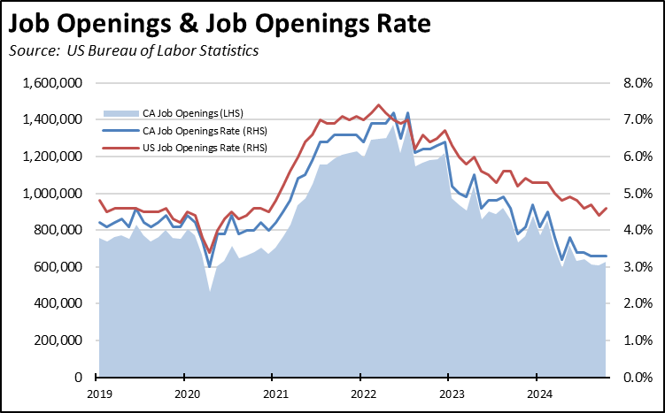

California’s high unemployment numbers combined with relatively low job openings puts the state at 1.7 unemployed for every available job opening. The US overall remains just within labor shortage conditions with 0.9 unemployed per job opening. **California has been the worst state as measured by this metric since September 2023, and currently is well above the next two worst states (Washington and Illinois) reporting only 1.3 unemployed per job opening.** California’s unemployment is growing, and the state does not have a sufficient level of jobs in the pipeline to bring it down.

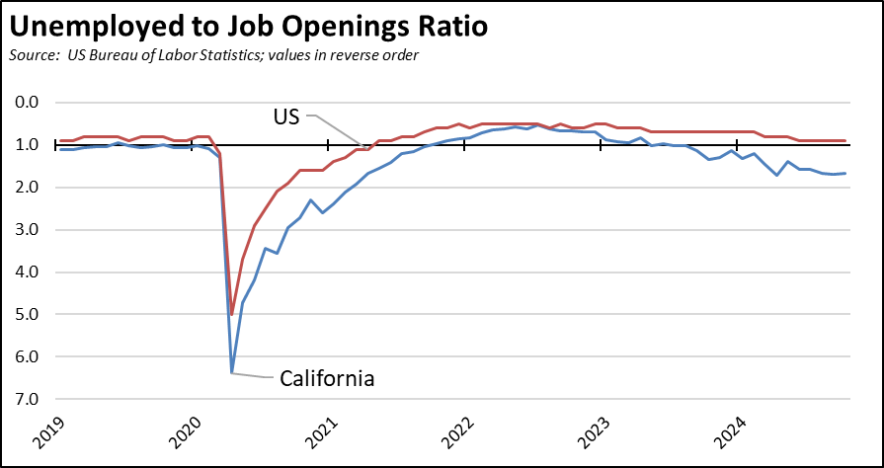

**CaliFormer Businesses**

Additional CaliFormer companies identified since our last report are shown below. The listed companies include those that have announced: (1) moving their headquarters or full operations out of state, (2) moving business units out of state (generally back office operations where the employees do not have to be in a more costly California location to do their jobs), (3) California companies that expanding out of state rather than locate those facilities here, and (4) companies turning to permanent telework options, leaving it to their employees to decide where to work and live. The list is not exhaustive but is drawn from a monthly search of sources in key cities.

|  |  |  |  |  |  |
| --- | --- | --- | --- | --- | --- |
| **Companies** | **From** | **To** | **Reason** | **Source** |  |
| Bavarian Nordic | San Diego | North Carolina | Biotech R&D closure | https://www.fiercebiotech.com/biotech/bavarian-nordic-plans-shut-down-san-diego-rd-site-laying-all-48-employees | 2024 |
| Castle Studios | Burbank | New Mexico | Studio expansion | https://www.yahoo.com/entertainment/virtual-film-studio-opens-northern-045436970.html | 2024 |
| Colovore | Santa Clara | Texas | $500 million data center | https://www.datacenterdynamics.com/en/news/colovore-plans-data-center-in-austin-texas/ | 2024 |
| Continuum | Cloverdale | Texas | HQ move and manufacturing expansion | https://www.bizjournals.com/houston/news/2024/11/21/continuum-moves-headquarters-to-houston.html | 2024 |
| Fortinet | Sunnyvale | Georgia | Expansion | https://www.bizjournals.com/atlanta/news/2024/11/22/fortinet-acquisition-cumberland-cobb-county.html | 2024 |
| Manufactured Packaged Products | Brea | various | Manufacturing relocation | https://finance.yahoo.com/news/glass-eps-manufacturing-hit-november-120000650.html?fr=sycsrp_catchall | 2024 |
| MentalHappy | San Francisco | Alabama | HQ relocation | https://www.bizjournals.com/birmingham/news/2024/11/25/mentalhappy-relocated-to-birmingham.html | 2024 |
| Xinquan | Fremont | Texas | Expansion | https://www.bizjournals.com/austin/news/2024/11/25/tesla-xinquan-automotive-trim-mustang-ridge-austin.html | 2024 |

**California GDP**

Include rpp

**County GDP Growth Rebounds in 2023 but at Subdued Levels**

Real GDP growth in 2023 showed expansion from the 2022 levels in 6 out of the 10 regions. Growth was strongest in the smaller primarily rural regions, while the Bay Area—the dominant factor in the state’s overall GDP growth and its budget condition—grew by only 3.3%. Among the other larger urban areas, Los Angeles was far weaker at 1.0%, with San Diego/Imperial at 1.9%, Inland Empire at 1.1%, Orange County at only 0.5%, Sacramento at 2.2%, and Central Valley at 2.5%. Note that Real GDP is calculated separately for each county. The numbers in the chart reflect aggregations for the constituent counties rather than separate estimates for each region.

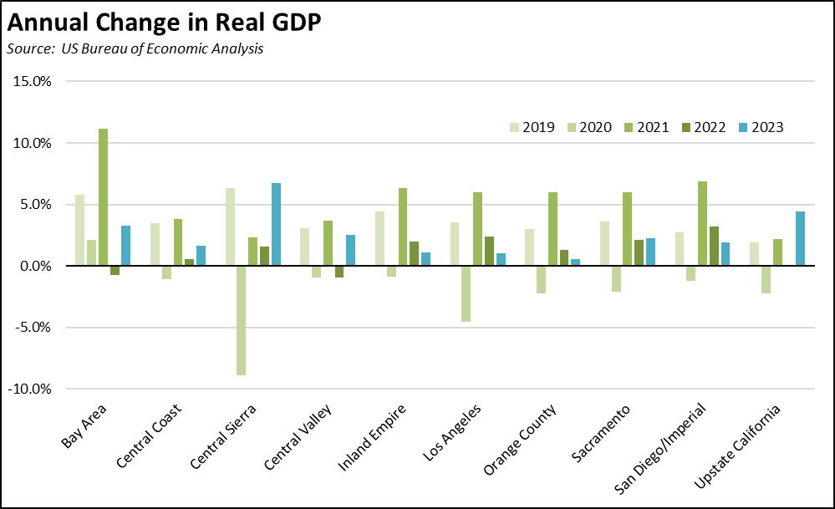

**State UI Fund Debt Nears $21 Billion**

The state’s continuing failure to address its burgeoning Unemployment Insurance debt saw the level near $21 billion. Current projections remain unknown as EDD has yet to release their October 2024 Unemployment Fund Forecast.

All other states other than New York have paid off their pandemic period debt, in large part using the federal funds provided for that purpose. California instead chose to use those funds on other expenditures.

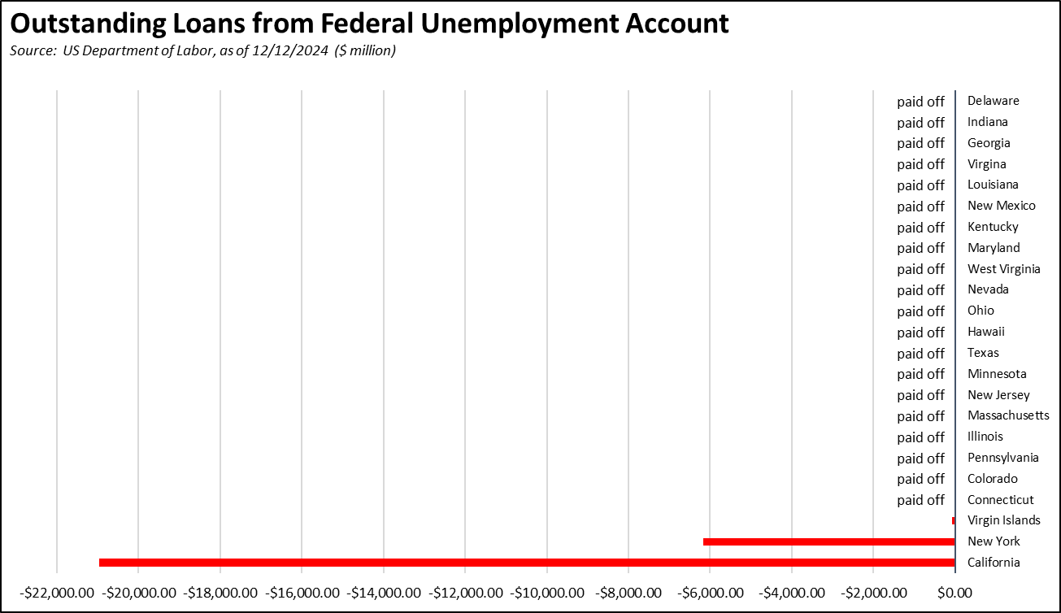

Measured on a 4-week moving average basis, the number of initial claims continues to rise but largely in tune with the trend from 2023.

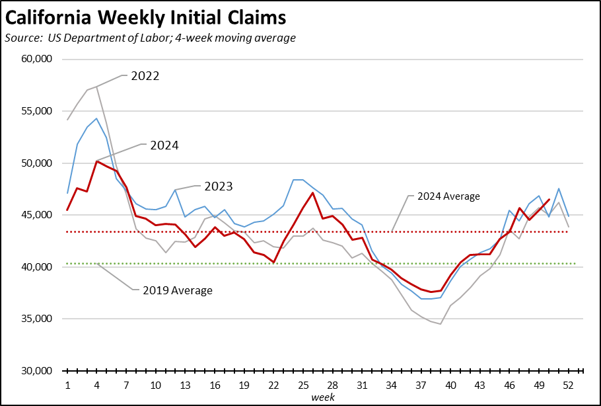

The number of workers receiving unemployment—as measured by insured unemployed (a proxy for continuing claims)—is now tracking somewhat above the 2023 levels, and also remains substantially above the levels in 2022.

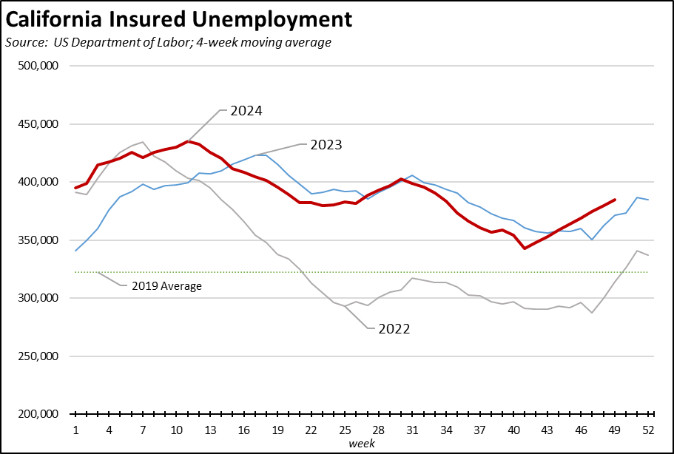

A recent [report](https://lao.ca.gov/Publications/Report/4943) by Legislative Analysts’ Office brings a needed focus to the fact that the state’s critical unemployment insurance program is functionally bankrupt. That report, however, focuses on the revenue side of the program. Missing from the analysis is the degree to which costs have driven the finances to the point that recovery is now questionable. The administration of the program has resulted in one of the most generous payout levels in the nation. While some of this situation is due to the state’s higher unemployment levels, a significant portion also relates to differences in how benefits are assessed and issued. While California contains 11.8% of all wage and salary jobs (2023), insured unemployment covered 24.2% of the national total in the latest results (4 week moving average), while initial claims were at 18.3%. In the latest 2023 data from US Bureau of Economic Analysis, 19.6% of all state unemployment insurance compensation nationwide was paid out by the California program.

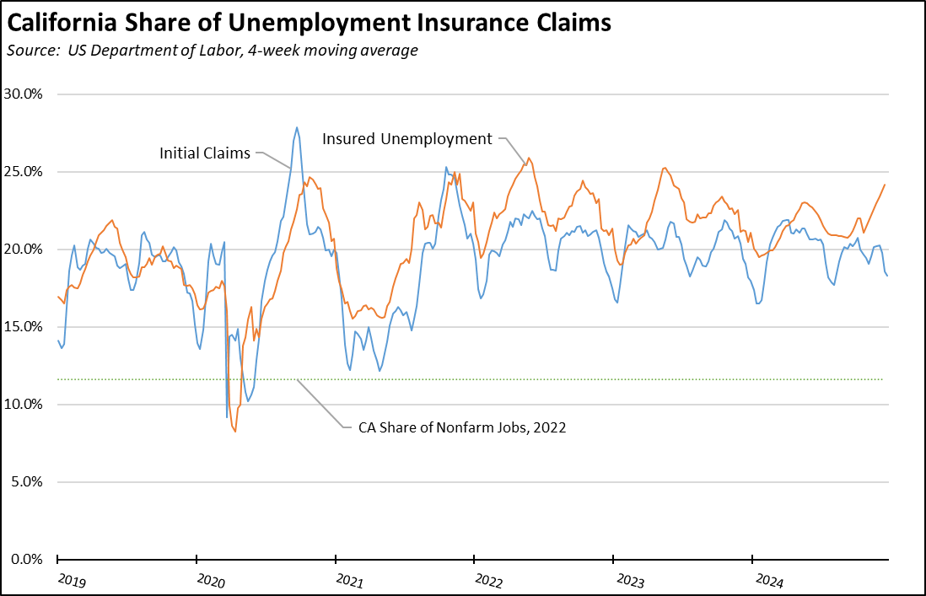

**California Real GDP Grows 3.1% in the 3rd Quarter**

US Bureau of Economic Analysis data shows California’s real GDP grew at an annualized rate of 3.1% in the 3rd Quarter, the 23rd highest among the states but matching the overall national average of 3.1%. This performance was higher than the 2.8% from the 2nd, but down from 6.3% in the 1st Quarter. Over the year (2023 Q3 to 2024 Q3), California grew 3.6%, the 9th highest among the states.

**California Personal Income Grows 3.6% in the 3rd Quarter**

US Bureau of Economic Analysis data shows California’s Personal income grew at an annualized rate of 3.6% in the 3rd Quarter, the 13th highest among the states and above the overall national average of 3.2%. California’s rate moderated substantially from 4.2% in the 2nd Quarter and 14.7% in the 1st Quarter. Over the year (2023 Q3 to 2024 Q3), California grew 6.3%, the 3rd highest among the states.

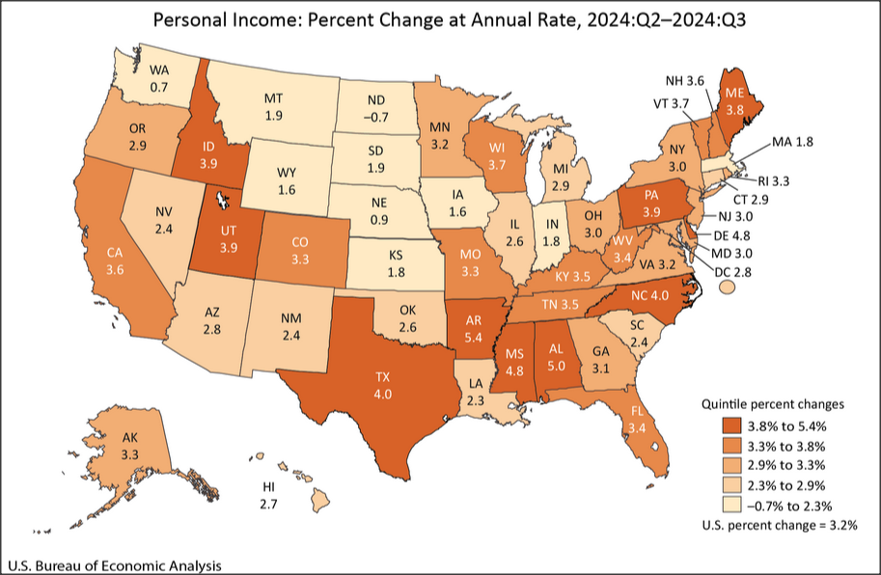

**California Grows 0.6% in 2024**

The US Census Bureau’s population estimates show California growing by 232,600 (0.6%) in 2024, up from 0.1% in 2023. Total estimated population is 39,431,000. About half the gain came from natural changes (births over deaths), while the remainder came from a recovery in international migration.

California continued to show a net outflow from domestic migration, with 239,600 more people leaving the state than moving here. This level was down somewhat from the 2023 outflow of 344,000.

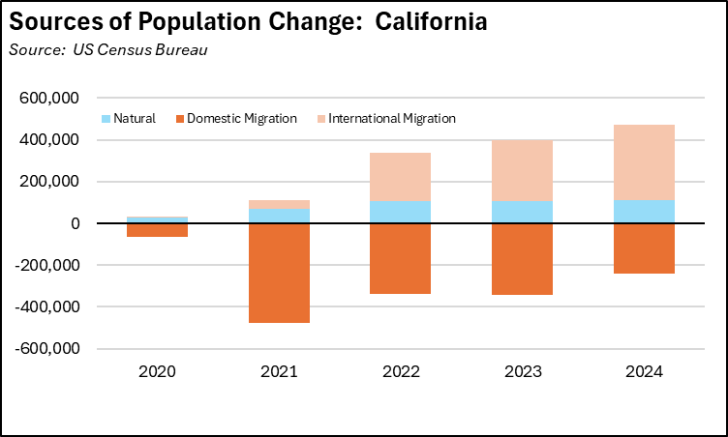

California’s population growth, however, is slowly substantially as both the resident population and foreign look for better economic opportunities and lower costs of living in other states. If California continued growing at the 2024 rate, the number of Congressional seats would drop from 52 in the current Congress to around 49 in the next redistricting. If instead it grew at the somewhat slower rate between 2019 and 2024, the number of seats would drop to around 48.