California Employment Report for April 2026

The Center for Jobs and the Economy has released our initial analysis of the April labor force and jobs data. For additional information and data about the California economy visit www.centerforjobs.org/ca.
Nonfarm Jobs Edge Down 3,300

In the preliminary numbers, seasonally adjusted nonfarm jobs showed little change with a loss of only 3,300. Year-to-date, nonfarm jobs now show a gain of 101,500 (0.6%) compared with the overall US gain of 0.2%. Coming after January’s high seasonal adjustment factor and the strike-affected February and March results, the April estimate is the first normalized result for the year.

The April preliminary result was the 2nd worst among the state, ahead of only New York. Job gains were led by Florida with 40,500 followed by North Carolina with 16,000 and Minnesota at 15,900.

Looking at net total nonfarm job gains compared to pre-pandemic peaks, California remained in 3rd place only somewhat ahead of much smaller North Carolina.

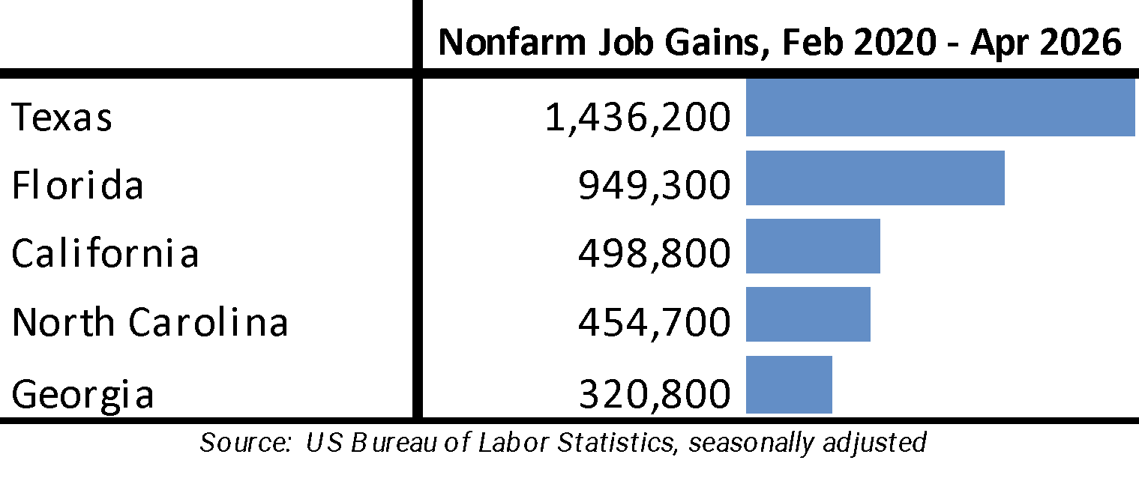

By industry, job gains came from government and government-supported Health Care & Social Assistance, with the Other Private industries on net contracted for the month and were largely unchanged for the year. Within the Other Private industries, gains over the year were heavily concentrated in lower wage Accommodation & Food Services, while contractions were in higher wage Information, Manufacturing, and construction.

Change in Nonfarm Jobs by Industry
Source: EDD, seasonally adjusted
 | From Mar 2026 | From Apr 2025
Total Nonfarm | -3,300 | 101,500
Government & Government Supported | 10,000 | 103,500
Government | 2,000 | -35,700
Health Care & Social Assistance | 8,000 | 139,200
Other Private | -13,300 | -2,000
Mining & Logging | -100 | 200
Construction | -700 | -14,500
Manufacturing | -2,300 | -17,000
Wholesale Trade | -2,500 | -6,600
Retail Trade | 2,400 | 6,200
Transportation, Warehousing & Utilities | 3,100 | -1,900
Information | -7,400 | -15,600
Finance & Insurance | -1,600 | -6,000
Real Estate & Rental & Leasing | -1,700 | -900
Professional, Scientific & Technical Services | -4,100 | 9,400
Management of Companies & Enterprises | -600 | -2,900
Administrative & Support & Waste Management & Remediation Services | -1,200 | -7,800
Private Educational Services | 3,500 | 12,100
Arts, Entertainment & Recreation | -2,300 | 1,300
Accommodation & Food Services | 2,700 | 30,500
Other Services | -500 | 11,500

California Unemployment Rate Tied for Highest Among the States

Seasonally Adjusted | California |  |  | US
 | Apr 2026 | Change from Mar 2026 |  | Apr 2026 | Change from Mar 2026
Unemployment Rate | 5.3% | 0.0 |  | 4.3% | 0.0
Labor Force | 19,720,100 | -0.3% |  | 169,995,000 | -0.1%
Participation Rate | 62.1% | -0.2 |  | 61.8% | -0.1
Employment | 18,674,300 | -0.2% |  | 162,622,000 | -0.1%
Unemployment | 1,045,900 | -0.7% |  | 7,373,000 | 1.9%

Not Seasonally Adjusted | California |  |  | US
 | Apr 2026 | Change from Apr 2025 |  | Apr 2026 | Change from Apr 2025
Unemployment Rate | 5.0% | -0.1 |  | 4.0% | 0.1
Labor Force | 19,532,800 | -1.3% |  | 169,548,000 | -0.6%
Participation Rate | 61.5% | -0.8 |  | 61.7% | -0.8
Employment | 18,565,500 | -1.1% |  | 162,781,000 | -0.8%
Unemployment | 967,300 | -4.5% |  | 6,768,000 | 2.8%

5.3%  CA Unemployment Rate | California’s seasonally adjusted unemployment rate was unchanged at 5.3%, and was tied with Delaware and Nevada for the highest among the states (DC was higher at 6.2%).  The US unemployment rate also was unchanged but at 4.3%.  Using a different calculation base (12-month average from Current Population Survey), unemployment rates by ethnicity/race ranged from 3.9% for Asians to an only marginally improved 9.6% for Blacks. Youth (age 16-19) unemployment was marginally worse at 23.8%.  Total number of unemployed was essentially unchanged, notching down by 7,500 and remaining above the 1 million level since January 2024. The number of unemployed nationally rose by 134,000.

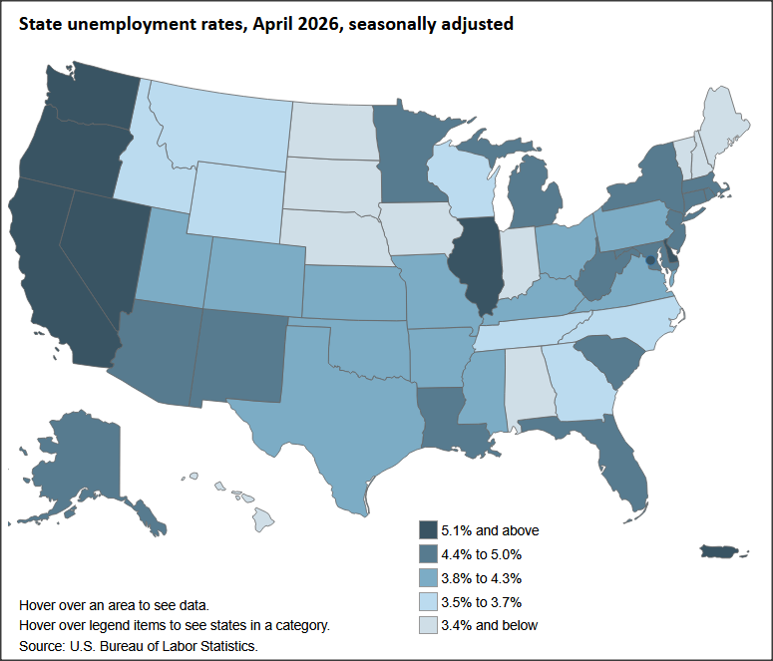
Interactive Original https://www.bls.gov/charts/state-employment-and-unemployment/state-unemployment-rates-map.htm

-42.6k  CA Employment | Employment fell by 42,600 (seasonally adjusted) in the preliminary estimate and was down 41,100 for the year.  Nationally, total employment was down 266,000 in the preliminary estimate for the month, and off 1.3 million for the year.

62.1%  CA Labor Force Participation Rate | California labor force (seasonally adjusted) edged down by 50,100, with the labor force participation rate level falling 0.2 point to 62.1%. The US labor force was little changed with a loss of 92,000, pushing the participation rate down 0.1 point to 61.8%.

Employment Recovery Progress

Due to the weak labor force numbers, California again remained just shy of recovery to its pre-pandemic employment levels. Adjusted by size, California’s performance edged down to 44th worst among the states and DC. As indicated in the chart, states with lower tax and lower regulatory burdens—including several adopting lower individual and business tax rates in recent years—have been far more successful in expanding employment opportunities for their populations.

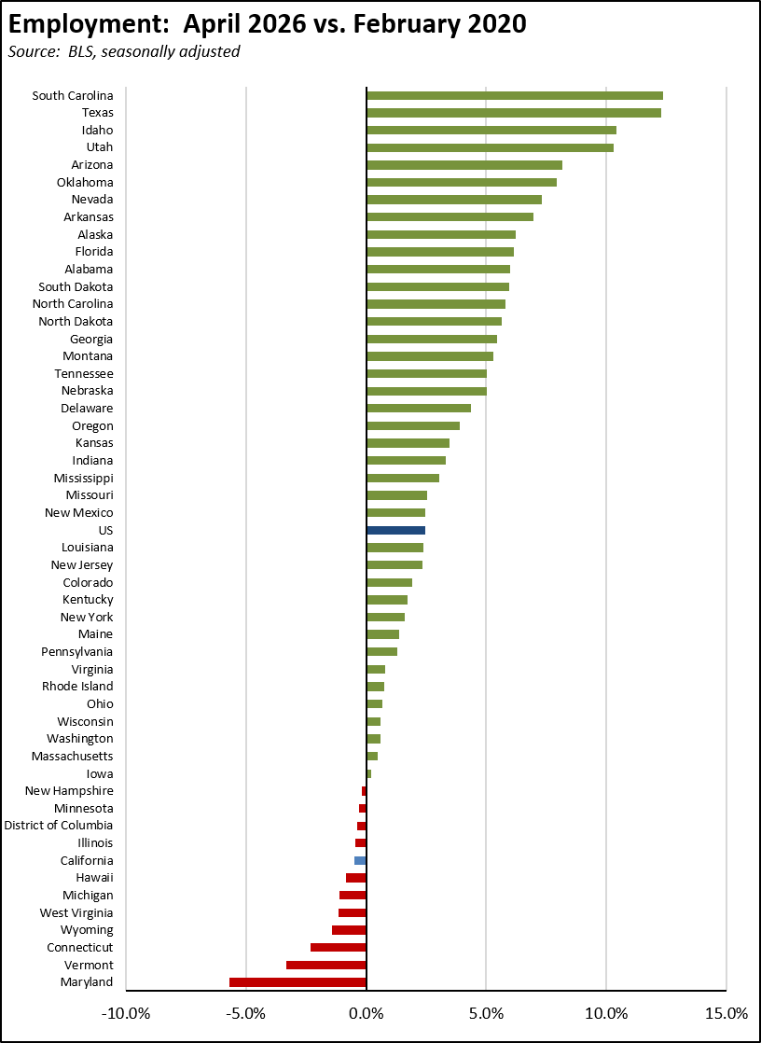

Nonfarm Jobs
-3.3k  Nonfarm Jobs Change | Nonfarm wage and salary jobs (seasonally adjusted) were essentially unchanged with a loss of 3,300, while March was revised up by 8,800 to a gain of 37,500, largely reflecting the end of the strikes that affected the February numbers.  For the US as a whole, nonfarm jobs rose 115,000 in the April preliminary estimate.

Recovery Progress: CA Nonfarm Jobs vs. Other States

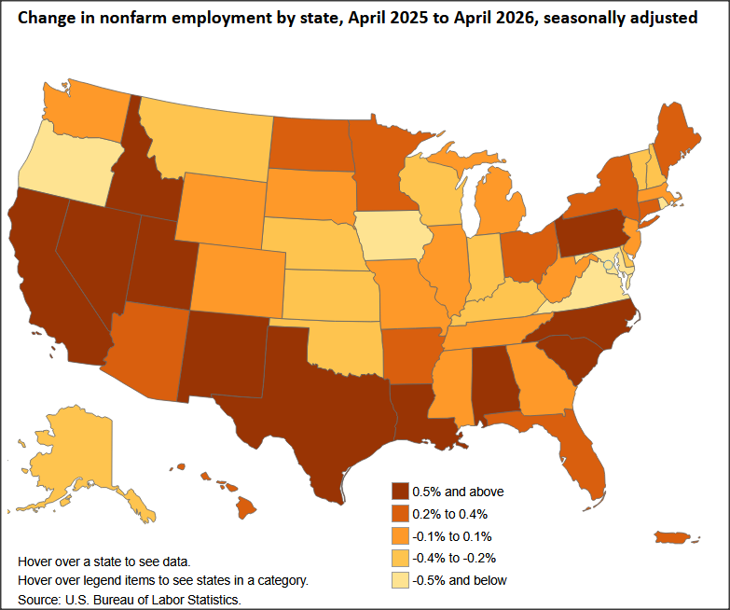
Interactive Original: https://www.bls.gov/charts/state-employment-and-unemployment/change-in-nonfarm-employment-by-state-map.htm

California’s monthly job performance in April was the second worst among the states and DC. Adjusted for size, California’s recovery level compared to the pre-pandemic peaks remained the 25th highest, while only 5 states and DC have yet to show positive recovery.

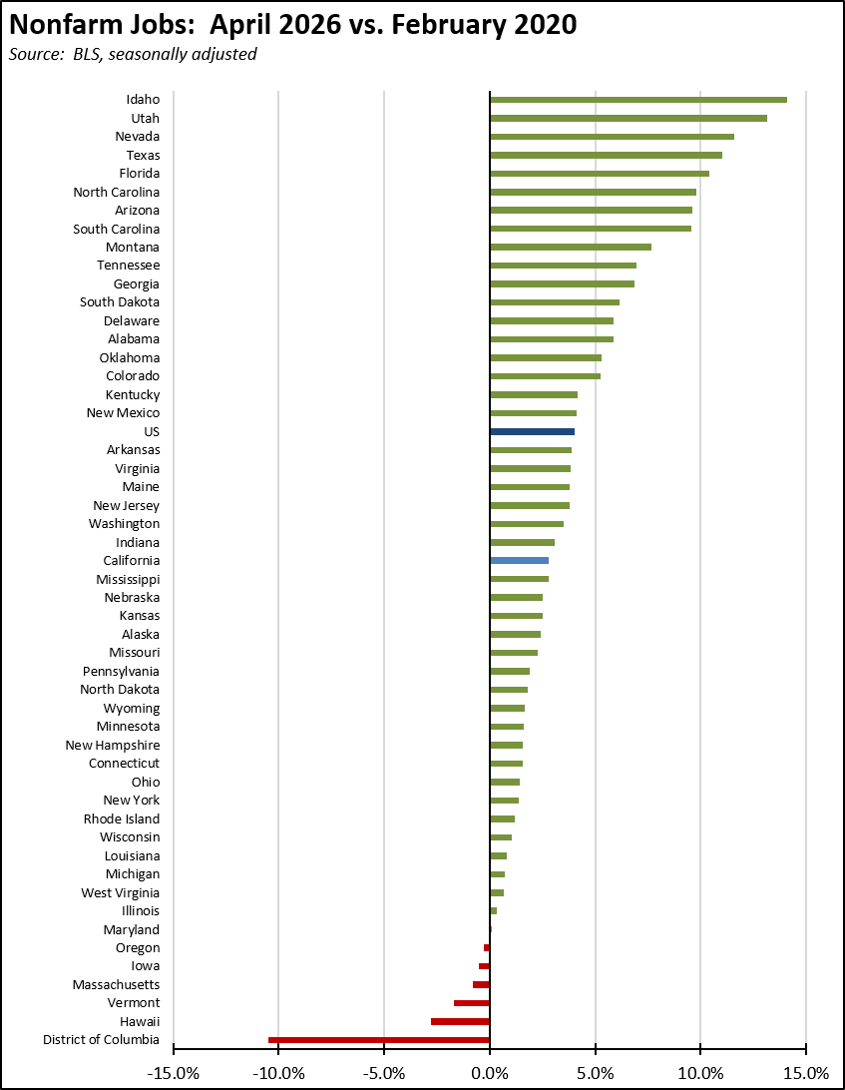

Wages & Hours

4.6%  12-month Change in Average Hourly Wage | In the seasonally unadjusted data, private average hourly wage rose 4.6% over the year, ranging from 0.6% in Information to 13.6% in Financial Activities. These higher labor costs, however, continued to be partially offset by a reduction in average weekly hours in most industries, with an overall loss of 1.5% for all private sector jobs. Combined with further offsets coming from 3.8% inflation in this period, as measured by US CPI, weekly earnings saw little real gain over the year.

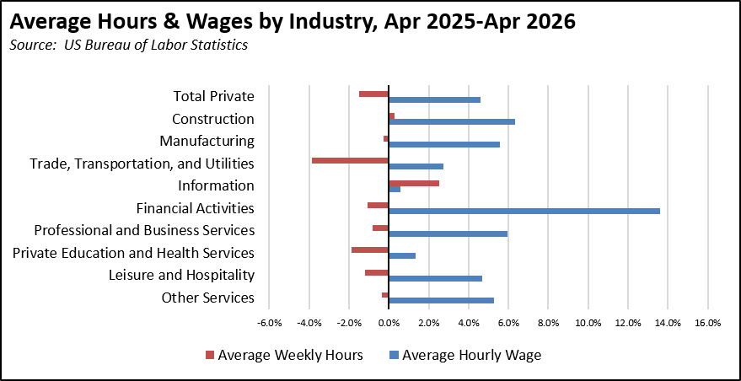

Unemployment Rates by Region

Unemployment rates (not seasonally adjusted) were higher in all regions compared to pre-pandemic February 2020 levels other than the Central Coast, Upstate California, and Central Valley.

Unemployment Rate by Region
Source: EDD, not seasonally adjusted
 | Apr-26 | Feb-20
California | 5.4 | 4.3
Orange County | 4.1 | 2.8
Bay Area | 4.4 | 2.7
Sacramento | 5.0 | 3.7
San Diego/Imperial | 5.3 | 3.8
Inland Empire | 5.4 | 3.9
Central Sierra | 5.6 | 4.5
Los Angeles | 5.6 | 4.3
Central Coast | 5.9 | 7.0
Upstate California | 6.2 | 6.3
Central Valley | 7.8 | 8.4

Counties with Double-Digit Unemployment

3  Counties with Unemployment Above 10% | The number of counties with an unemployment rate (not seasonally adjusted) at 10% was at only 3. The unadjusted rates ranged from 3.2% in Mono to 16.5% in Imperial.
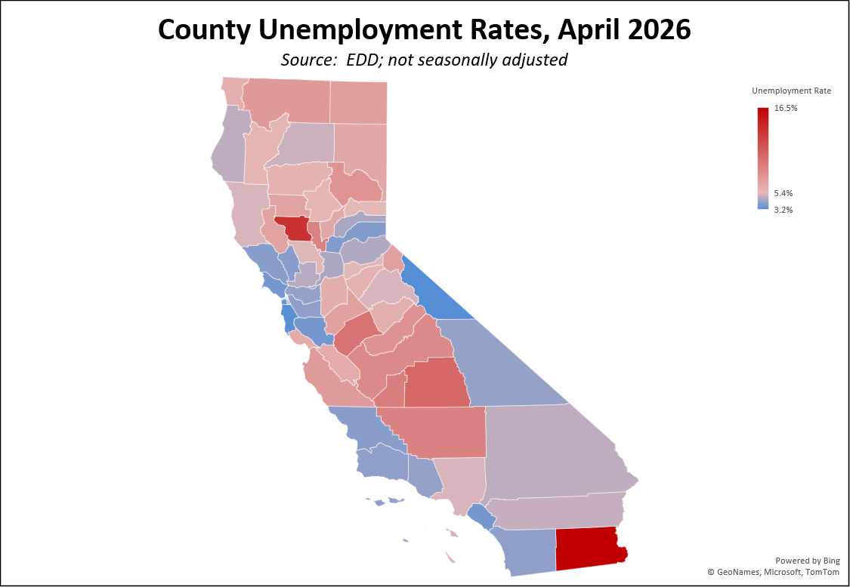

Unemployment Rate by Legislative District

The estimated unemployment rates are shown below for the highest and lowest districts. The full data and methodology are available on the Center’s website.

Lowest | SD40 Jones (R) | 3.3 | AD76 Maienschein (D) | 3.1
 | SD13 Becker (D) | 3.3 | AD19 Ting (D) | 3.2
 | SD38 Blakespear (D) | 3.5 | AD23 Berman (D) | 3.2
 | SD11 Wiener (D) | 3.5 | AD16 Bauer-Kahan (D) | 3.3
 | SD37 Min (D) | 3.7 | AD72 Dixon (R) | 3.3
 | SD10 Wahab (D) | 3.8 | AD21 Papan (D) | 3.4
 | SD34 Umberg (D) | 3.8 | AD26 Low (D) | 3.5
 | SD36 Nguyen (R) | 3.8 | AD68 Valencia (D) | 3.5
 | SD15 Cortese (D) | 3.8 | AD75 Waldron (R) | 3.6
 | SD09 Skinner (D) | 3.9 | AD77 Boerner Horvath (D) | 3.7
Highest | SD26 Durazo (D) | 5.7 | AD03 Gallagher (R) | 6.5
 | SD01 Dahle (R) | 6.0 | AD39 Carrillo (D) | 6.7
 | SD04 Alvarado-Gil (D) | 6.0 | AD22 Alanis (R) | 6.8
 | SD35 Bradford (D) | 6.0 | AD57 Jones-Sawyer (D) | 7.0
 | SD28 Smallwood-Cuevas (D) | 6.1 | AD32 Fong (R) | 7.2
 | SD17 Laird (D) | 6.2 | AD36 Garcia (D) | 9.3
 | SD12 Grove (R) | 6.6 | AD27 Soria (D) | 9.4
 | SD18 Padilla (D) | 7.3 | AD35 Bains (D) | 9.5
 | SD14 Caballero (D) | 9.8 | AD31 Arambula (D) | 10.0
 | SD16 Hurtado (D) | 10.3 | AD33 Mathis (R) | 10.9

