California Trade Report
for April 2026
Below are highlights from the recently released trade data from the US Census Bureau and US Bureau of Economic Analysis. The data reflects the annual revision process, with the trade data revised beginning in 2021. To view additional data and analysis related to the California economy visit our website at www.centerforjobs.org/ca.

Total trade through the state’s ports remained strong in April, with trade levels in the first 4 months of the year at their highest measured in both nominal and real terms. California’s share of total US goods trade (on a 12-month moving average basis) rose for the 4th month in a row to 16.92%, still well below the state’s historic peaks but the highest since January 2022.

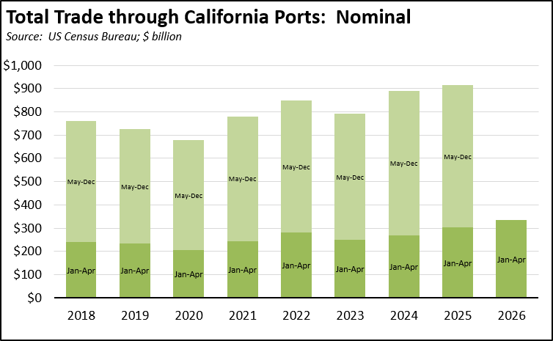

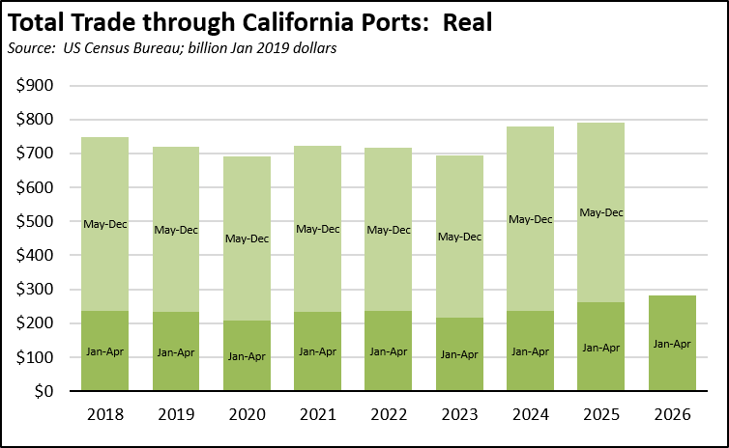

State origin exports were off $1.2 billion (-6.7%) compared to the prior month, but were up $1.2 billion (7.7%) compared to the same month in 2025. Destination imports were little changed over the month (down $0.6 billion (-1.3%)) but were up sharply ($4.4 billion (11.5%)) compared to April 2025.

Trade price levels rose higher. Import prices (all goods) were up 27.9% on an annualized basis for the month and 4.3% for the year. Reflecting the growing importance of energy exports to other states, export prices (all goods) were substantially higher, at 47.6% on an annualized basis for the month and 8.8% over the year.

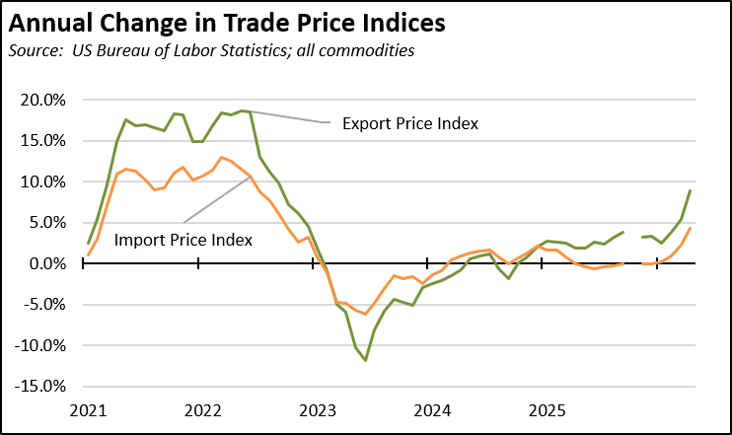

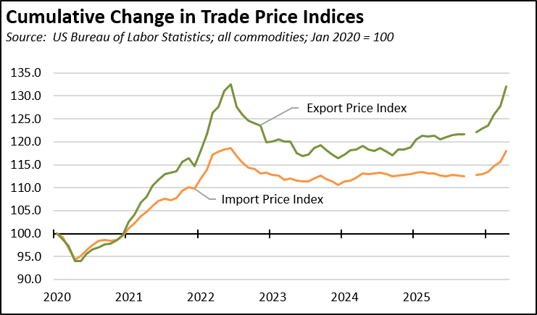

Removing the more volatile energy component, import prices for other goods showed substantially more moderation, rising 2.9% over the year.

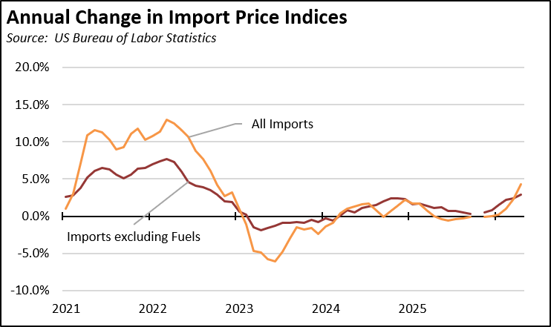

Share of Goods through US Ports
16.9% | The share of total US goods trade (exports and imports) through California ports edged up to 16.92% (12 month moving average; compared to 16.56% in March 2026 and 16.62% in April 2025).
CA Share of Total Trade
Through US Ports
CA Share of Total Trade  Through US Ports | California remained the #2 state, behind Texas which had a 22.02% share (compared to 20.59% in March 2026 and 19.38% in April 2025). Trade through the Atlantic port states was at 29.85% (compared to 29.24% in March 2026 and 30.08% in April 2025). These trade flows form the trade-related base for one of California’s largest centers of middle-class, blue-collar jobs.
California Goods Exports
$1.2 | Total California origin goods exports were down $1.2 billion from April 2025 (down 7.7%). California remained in 2nd place with 8.31% of all US goods exports (12 month moving total), behind Texas at 20.65%.
Billion Change in Exports
California Goods Imports
$4.4 | Total California destination goods imports grew $4.4 billion from April 2025 (up 11.5%).
Billion Change in Imports
Top 20 Exports, April 2026
Top 20 exports by value are shown below, along with the change from Apr 2025.
NAICS Commodity | Apr 2026 Exports ($b.) | Change from Apr 2025
Computer Equipment | $1.9 | 31.8%
Fruits & Tree Nuts | 1.1 | 4.8%
Aerospace Products & Parts | 1.0 | 42.8%
Semiconductors & Other Electronic Components | 0.9 | 38.4%
Navigational/measuring/medical/control Instrument | 0.8 | -3.3%
Pharmaceuticals & Medicines | 0.6 | -2.4%
Communications Equipment | 0.6 | -16.4%
Petroleum & Coal Products | 0.5 | 60.9%
Medical Equipment & Supplies | 0.5 | -9.8%
Electrical Equipment & Components, Nesoi | 0.4 | -15.0%
Waste & Scrap | 0.4 | 14.6%
Industrial Machinery | 0.4 | -4.2%
Commercial & Service Industry Machinery | 0.4 | -21.1%
Other Fabricated Metal Products | 0.3 | 6.7%
Motor Vehicle Parts | 0.3 | 0.9%
Transportation Equipment, Nesoi | 0.3 | 720.2%
Miscellaneous Manufactured Commodities | 0.3 | -11.9%
Electrical Equipment | 0.3 | 27.4%
Other General Purpose Machinery | 0.3 | -27.1%
Basic Chemicals | 0.3 | 34.7%
Top 10 Export Markets, April 2026
 | Apr 2026 Exports ($b.) | Change from Apr 2025
Mexico | $2.8 | 4.2%
Taiwan | 1.3 | 26.3%
Canada | 1.3 | -13.7%
Japan | 1.1 | 15.2%
China | 0.9 | -4.2%
Korea, South | 0.7 | -2.5%
Netherlands | 0.7 | -10.3%
Singapore | 0.5 | 40.7%
Germany | 0.5 | 2.5%
Hong Kong | 0.5 | 32.6%

