California Energy Price Data for
December 2025
Below are the monthly updates from the most current December 2025 fuel price data (GasBuddy.com) and October 2025 electricity and natural gas price data (US Energy Information Administration). To view additional data and analysis related to the California economy visit our website at www.centerforjobs.org/ca.

California’s energy cost rankings again generally remained unchanged even with the changeover to the less costly and higher supply producing winter formulations for fuels. As in the past few months, the average electricity bill rank again showed marginal improvement as costs continued to rise elsewhere in the country as the result of fall and winter weather combined with factors such as natural gas pipeline restrictions in some states.

 | Energy Price (12-month moving average; fuels monthly) | Rank Among Contiguous States
 | Energy Price (12-month moving average; fuels monthly) | Current Month | Previous Month
 | Residential Electricity Rate | 1 | 1
 | Average Residential Electricity Bill | 16 | 15
 | Commercial Electricity Rate | 1 | 1
 | Industrial Electricity Rate | 1 | 1
 | Residential Natural Gas Rate | 3 | 3
 | Commercial Natural Gas Rate | 3 | 3
 | Industrial Natural Gas Rate | 5 | 5
 | Gasoline | 1 | 1
 | Diesel | 1 | 1
Data Centers

Californians have suffered from rising electricity costs over the past 15 years that have taken the state to the highest average electricity rates among the contiguous states, ranging from residential rates that are 96.7% higher than the average for all other states to industrial rates that are an anti-competitive 171.9% higher. As electricity rates have recently risen in other states as well, data centers have become the latest fad in a series of finger-pointing attempting to distract from the cost effect of policies embraced by several states including California to mandate specific electric generation technologies and even projects. Data Centers, especially the current surge in new centers required for the further development and use of AI, have increasingly been criticized as the cause of rising utility bills along with creating water supply problems as well. The electricity cost argument is addressed in the analysis below. The water issue has been put in proper perspective in more detail in other sources.

The analysis considers two potential cost factors and their effect on current state average electricity prices: data centers and state generation restrictions under their climate change programs. The analysis uses relatively simple linear regression models to assess the relative contributions of these two factors to assess whether the data center contention holds any water. The analysis does not address the many other factors that go into the determination of electricity rates in each state—an exercise somewhat beyond the ability of a monthly report—but instead focuses on these two key elements. As such, the results suggest where policy actions to help resolve the current cost rises should focus.

Data Sources. Data used in the analysis is taken from the following sources. While additional sources may be available, in general we continue to prefer publicly accessible data in keeping with our effort to keep our analyses as fully transparent as possible. Anyone with questions or criticisms of our results consequently is able to “play at home along with us” and access the same data and crunch it on their own.

Data Center data is generally not available in any sort of definitive form. There are a number of different sources that provide some publicly accessible summaries, but these vary widely in their counts and additional information such as size and capacity. For example, some of the more often used sources include: Aterio listing 1,938 existing centers (plus 608 under construction and 2,669 announced) along with their estimated power capacity, Hitachi Energy which has no accessible summaries but which is used in some Department of Energy reports, Data Center Map listing 3,770 centers by state but with no additional information, and Business Insider listing 1,240 existing centers along with estimated annual power consumption. In most cases, the numbers in the different sources shown for the major data center states are closer than the overall totals. Some of the key reasons behind the differences appear to be whether just existing centers are covered or under construction and proposed are included as well, and the extent to which small and medium centers, especially those associated with a larger operation, are included. These sources also treat crypto mining operations inconsistently.

For the analysis, several different data center measures were assessed, including the capacity and power consumption numbers as above along with data center power use as a share of each state’s total, as taken from the 2024 EPRI report generally cited as the source of this data point.

State energy policies are assessed as a binary data point (1 if the state has such a policy and 0 if not) for the various state energy policies covered in the most recent updated Lawrence Berkeley National Laboratory Report on U.S. State Electricity Resource Standards. The analysis considered 4 different policy levels maintained by the states: Renewal Portfolio Standard (RPS) requiring electricity retail providers to obtain specified percentages of their power from specified renewable generation sources, RPS requiring 50% or more renewables, RPS requiring 100% renewables, and a Clean Energy Standard that is similar to an RPS but can cover a broader range of “clean” technologies such as nuclear and fossil fuel with carbon capture.

Electricity costs come from the US Energy Information Administration data used in these reports. Different specifications were analyzed, including current average cost per kWh (12-month average ending in the most recent month available, October 2025) for both residential users and total electricity users, and change (both absolute and percentage) comparing the most recent 12-month period with the same period ending October 2020 (the inflection point for the current acceleration in California costs) and ending October 2022 (just prior to the announcement of ChatGPT).

Results. After considering a large number of combinations, the two best regression outcomes are shown in the tables below. In summary:

- The data center specifications were significant only in a few instances, and even then generally at the 90% confidence interval rather than 95%. The outcomes below include one of the few instances where this factor was significant at the 95% level.

- The data center coefficients were negative in all the cases assessed. While this may be counterintuitive given the tone of recent press coverage, these outcomes suggest that at least to date, data center power usage has not increased state power costs. The negative cost effect instead may be due to a number of factors, including: data centers improve base load consumption levels, leading to more efficient use of the generation system and spreading grid and other capital costs over that broader base; improved base load consumption makes better use of renewable generation when it is available; similarly, this consumption is better positioned to access excess renewable generation when it is available, such as California’s dumping at times of renewable power at fire sale prices; data centers maintain backup power in sufficient quantity to provide a grid benefit during shortages or outages; and many recent projects especially larger project and project concentrations have moved to secure their own power sources, overall increasing grid reliability at their own rather than ratepayer expense. Alternatively, states with more data center development may simply be paying more attention and management both the cost and reliability of their systems, while the experience in California has been to forge ahead with the RPS and associated climate change goals often regardless of cost.

- The energy policy specifications were generally significant across the different cases assessed, but also generally at the higher and more costly range of these policies, namely RPS of 50% or over and RPS of 100% as in California. CES was not significant in any case.

- Looking the results below, having a RPS of 50% or more is associated with 6.2 cents added to the average residential electricity rate in the states, a RPS of 100% added 5.9 cents more, and having a data center consumption share equivalent to California’s reduced the rate by 1.1 cents. For total average electricity rate, a RPS of 50% or more added 5.1 cents to the cost, a RPS of 100% added 6.8 cents more, and data center consumption equivalent to California again reduced the rate by 1.1 cents.

- Overall, both equations indicate these two factors cover more than 40% of the variance in state electricity rates.

Regression Results
Variable | Coefficient
Dependent: Average Residential Rate
Intercept | 16.44*
 | (0.95)
Data Center Share of State Consumption | -30.66***
 | (14.25)
RPS 50% + | 6.17*
 | (1.63)
RPS 100% | 5.94*
 | (2.88)
Adj. R² | 0.4149
Observations | 51
Dependent: Average Total Rate
Intercept | 13.31*
 | (0.88)
Data Center Share of State Consumption | -30.21**
 | (13.17)
RPS 50% + | 5.05*
 | (1.51)
RPS 100% | 6.80**
 | (2.66)
Adj. R² | 0.4588
Observations | 51
Standard errors in parentheses
*99% significance, **95% significance, ***90% significance

The absence of a data center impact to date is also shown by looking at the data itself. The charts below compare data centers by share of total state electricity consumption from the EPRI data to the change in average state electricity rates from pre-ChatGPT 2022 (12 months ending October that year) to the most recent results for the same period ending in 2025. Both average total electricity rate and average residential rate are shown from the US EIA data.

As indicated, there is no clear association between the level of data centers in a state and the scale of cost increases experienced in utility rates. Taking just the first chart, California with substantially stricter RPS and associated standards saw the average total rate increase just short of 25% while having data centers drawing on only 3.7% of its power. Virginia at the extreme has seen a rate rise of only 8% while being ground zero for data center development, which takes up 25.6% of its power sales. The same pattern or rather lack of a pattern is seen for residential rates as well.

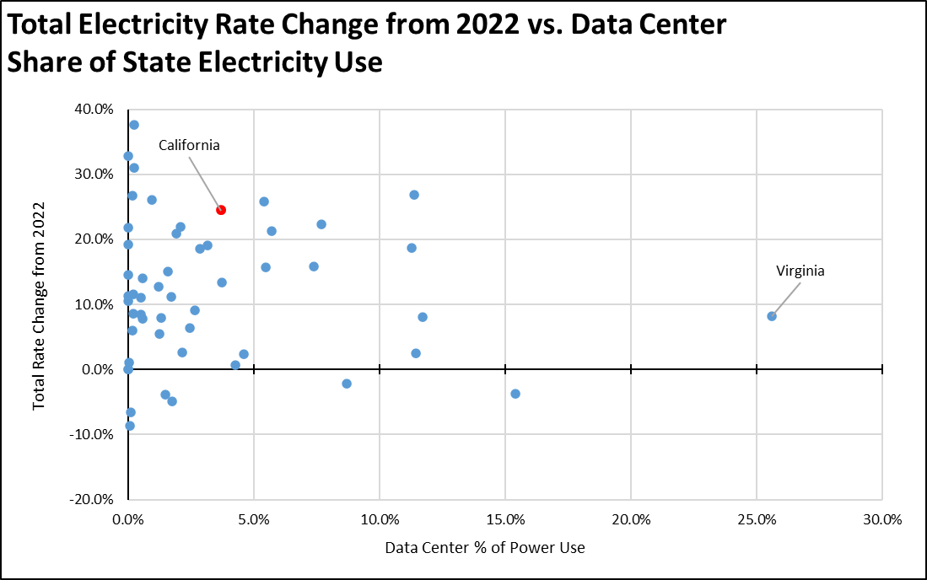

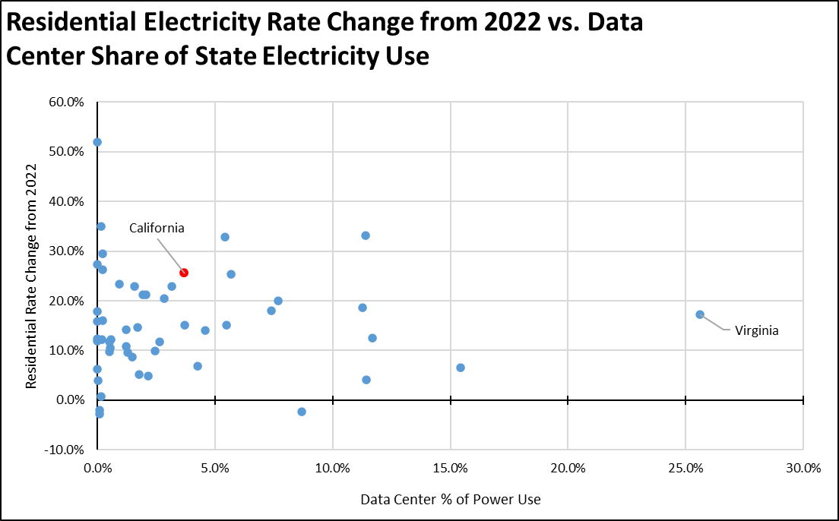

Combining the data, the states with data centers using more than 10% of their electricity had an average total rate increase in this period of 10.1%, while all states with data center usage of 5% or less had a somewhat higher average rate increase of 12.0%. For residential rates, the respective increases were 15.4% for the high data center states and 15.1% of the low data center states, essentially no difference that again shows no identifiable data center effect.

The current but recent focus on data centers as a cost of living driver only serves to distract from the real cost issues affecting households and employers, namely the tendency of states especially this state to enact policies without a real consideration of the potential costs. And this tendency is often made worse by an unwillingness to acknowledge policy shortcomings when they occur and make necessary course directions. This is the process that moved California from a state where reliable and affordable energy once served as the base for a thriving middle class economy, to the bifurcated two tier economy we are now in.

The current data center trends are critical to the California economy as it is today, and it is important to keep in mind that these developments to a substantial degree serve California companies and enable the next phase of the Silicon Valley base on which the state now overly depends for its GDP performance, for incomes, and critically for a substantial and growing share of state revenues. But as usual with state policies, California is again going for the gold while pushing off this component to other states as operators seek affordable and more reliable electricity. California has done serious harm to the costs of living and costs of doing business through its energy policies. In this instance, those policies have served to once again force others to live with the consequences of its decisions.

Inflation
n/a | Due to the federal budget impasse, data for the CPI was not collected in October, affecting the calculations for the September California CPI. This data will be updated as the federal data continues to resume.
Increase Since August 2025
California vs. Rest of US Fuel Price Gap at 57.1% Premium
$1.58 | The December average price per gallon of regular gasoline in California eased 29 cents from November to $4.34. The California regulatory and tax premium above the average for the US other than California ($2.76) eased to $1.58, a 57.1% difference.
Price Per Gallon
Above Other States
(CA Average)
1st | In December, California had the highest gasoline price among the contiguous states and DC. Californians paid $2.05 a gallon more than consumers in Oklahoma, the state with the lowest price.
Ranked by
price
California Gasoline Taxes & Fees
$1.42 | As discussed in prior reports, the Energy Commission has not updated their fuel tax and fee calculations since March 2025, and in spite of arguing that they required the data to properly monitor fuel pricing through SB 1322 (2022), has not updated their fuel net margin analysis since March 2024. In the absence of current Energy Commission data, we are making our own estimates using the Commission factors and the new OPIS data. In December, $1.42 (32.8%) of the price of a gallon of regular gasoline was paid to cover state, local, and federal taxes and fees.
Total Taxes & Fees per Gallon of Gasoline
California Carbon Taxes: LCFS and Cap & Trade
Per Gallon Carbon Taxes, December 2025
Source: OPIS adjusted to include sales tax
 | LCFS | Cap & Trade | Total
Gasoline | $0.15 | $0.27 | $0.42
Diesel | $0.17 | $0.34 | $0.52

In December, total LCFS charges incorporated in the price Californians pay for fuel rose 1 cent for gasoline but were unchanged for diesel, while the Cap & Trade component showed a 1 cent improvement for both. Combined charges for both fuels were unchanged. The costs shown in the table are for the penultimate month-to-date numbers from the OPIS Carbon Market Report, adjusted to incorporate state and local sales tax to account for the full additional costs imposed by these regulatory fees on fuel buyers. Certain Data or Information Provided By: Oil Price Information Service, LLC. Distribution of OPIS data without permission from OPIS is prohibited.
Combining the OPIS data (without the sales tax component) with the previous Energy Commission estimates, both charges have shown relative stability in the past few months. Note that both charts include both the Cap & Trade components charged at the rack and levied on production from the OPIS data, and only the rack component in the Energy Commission data.

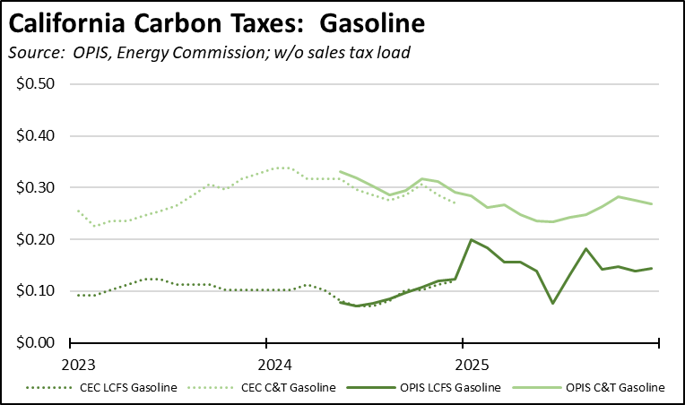

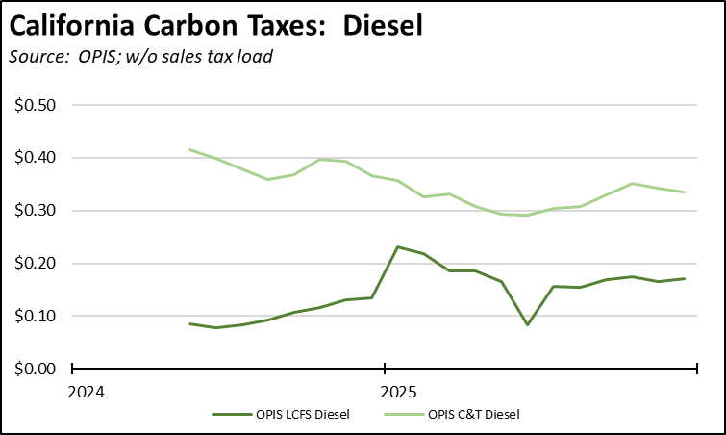

The cost effect of the amended LCFS regulations continues to be moderated by the high level of banked credits. Overall, credit prices have been largely level, showing only a marginal change since the end of July on a 4-week moving average basis, with trade volumes and prices moderated further by the shift to winter formulation. This price moderation and the resulting stable impact on fuel prices stem from the continued run-up in banked credits, which reached their highest level yet of 43.0 million in the 2nd quarter just prior to the effective date of the amended regulations. As the increasingly stricter standards under the amended regulations begin to eat away at this buffer, credit prices and the consequent costs to households and employers will begin trending back up towards historical levels.

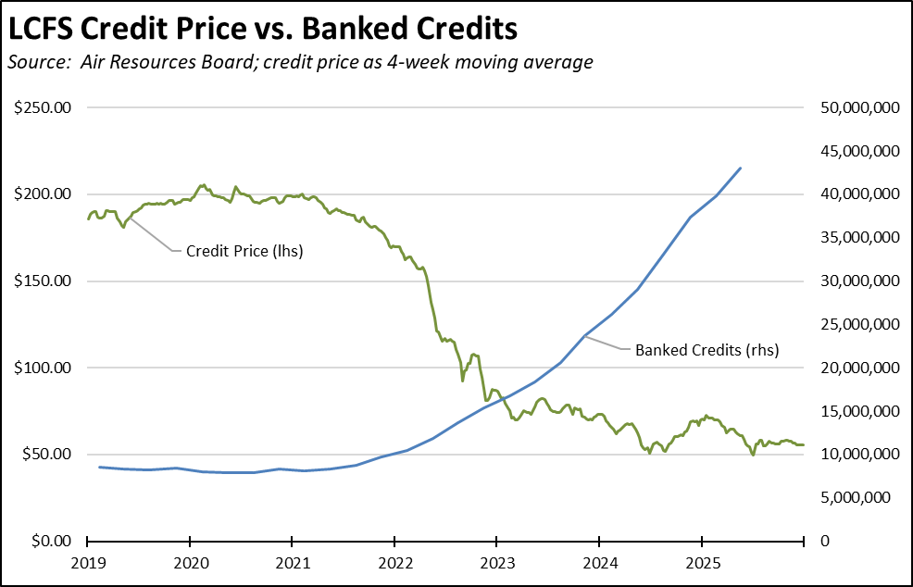

In the most recent auction of Cap & Trade credits held November 19, all credits offered by CARB were sold, resulting in proceeds of $844.2 million. To date, the auctions have had total proceeds—ultimately paid by California households and employers—of $1.7 billion in the fiscal year.
California vs. Rest of US Diesel Price
$1.47 | The December average price per gallon of diesel in California eased 18 cents from November to $4.97. The California regulatory and tax premium above the average for the US other than California ($3.51) eased to $1.47, a 41.8% difference.
Price Per Gallon
Above Other States
(CA Average)
1st | In December, California had the highest diesel price among the contiguous states and DC.
Ranked by
price
Range Between Highest and Lowest Prices by Region
$1.75 | The cost premium above the US (other than California) average price for regular gasoline ranged from $1.44 in the Central Valley Region (average December price of $4.20), to $1.75 in San Diego/Imperial Region (average December price of $4.51).
Price per Gallon above Other States (San Diego/Imperial Region)
Highest/Lowest Fuel Prices by Legislative District:
December 2025: Average Price ($ per gallon) of Regular Gasoline
 | Highest
CD30 Friedman (D) | $4.68
CD27 Whiteside (R) | $4.62
CD36 Lieu (D) | $4.61
CD52 Vargas (D) | $4.61
CD32 Sherman (D) | $4.60
SD24 Allen (D) | $4.64
SD39 Weber (D) | $4.61
SD26 Durazo (D) | $4.60
SD28 Smallwood-Cuevas (D) | $4.57
SD38 Blakespear (D) | $4.54
AD51 Zbur (D) | $4.79
AD44 Schultz (D) | $4.65
AD78 Ward (D) | $4.64
AD77 Boerner (D) | $4.62
AD80 Alvarez (D) | $4.61
 | Lowest
CD21 Costa (D) | $4.15
CD17 Khanna (D) | $4.13
CD06 Bera (D) | $4.13
CD01 LaMalfa (R) | $4.06
CD09 Harder (D) | $4.02
SD15 Cortese (D) | $4.15
SD10 Wahab (D) | $4.14
SD06 Niello (R) | $4.12
SD01 Dahle (R) | $4.11
SD05 McNerney (D) | $4.11
AD10 Nguyen (D) | $4.10
AD09 Flora (R) | $4.09
AD22 Alanis (R) | $4.05
AD13 Ransom (D) | $3.96
AD03 Gallagher (R) | $3.94
California Residential Electricity Price
96.7% | California average Residential Price for the 12 months ended October 2025 was 32.04 cents/kWh, 96.7% higher than the US average of 16.29 cents/kWh for all states other than California. California's residential prices were the highest among the contiguous states and DC.
Above Average for Rest of US
California Residential Electric Bill
16th | For the 12 months ended October 2025, the average annual Residential electricity bill in California was $1,876, or 88.7% higher ($882) than the comparable bill in 2010 (the year the AB 32 implementation began with the Early Action items). In this same period, the average US (less CA) electricity bill for all the other states grew only 31.3% ($427).  In 2010, California had the 9th lowest residential electricity bill among the contiguous states and DC. In the latest data as portions of the nation experienced higher winter costs, it tied with Delaware for the 16th highest.
Ranked by Cost
 | Residential bills, however, vary widely by region. Transforming the 2022 data from the Energy Commission, estimated annual household usage is as much as 82% higher in the interior regions compared to the milder climate coastal areas, and substantially higher when comparing across counties.
$13.1b | For the 12 months ended October 2025, California's higher electricity prices translated into Residential ratepayers paying $13.1 billion more than the average ratepayers elsewhere in the US using the same amount of energy. Compared to the lowest cost state, California households paid $17.0 billion more.
Above Average for Rest of US
California Commercial Electricity Price
109.8% | California average Commercial Price for the 12 months ended October 2025 was 25.81 cents/kWh, 109.8% higher than the US average of 12.30 cents/kWh for all states other than California. California's commercial prices were the highest among the contiguous states and DC.
Above Average for Rest of US
California Industrial Electricity Price
171.9% | California average Industrial Price for the 12 months ended October 2025 was 21.64 cents/kWh, 171.9% higher than the US average of 7.96 cents/kWh for all states other than California. California's industrial prices were the highest among the contiguous states and DC.
Above Average for Rest of US
$21.2b | For the 12 months ended October 2025, California's higher electricity prices translated into Commercial & Industrial ratepayers paying $21.2 billion more than ratepayers elsewhere in the US using the same amount of energy. Compared to the lowest rate states, Commercial & Industrial ratepayers paid $27.6 billion more.
Above Average for Rest of US
California Natural Gas Prices
Average prices ($ per thousand cubic feet; 12-month moving average) for the 12 months ended October 2025 and changes from the previous 12-month period for each end user:
 | Residential | Commercial | Industrial
CA, October 2025 | $21.29 | $15.86 | $12.64
CA, October 2024 | $19.49 | $14.01 | $11.58
Change | 9.2% | 13.2% | 9.2%
Rest of US, October 2025 | $14.28 | $10.32 | $4.33
Rest of US, October 2024 | $14.66 | $9.79 | $3.33
Change | -2.6% | 5.4% | 30.0%
CA premium over Rest of US, October 2025 | 49.1% | 53.7% | 191.9%
CA premium over Rest of US, October 2024 | 32.9% | 43.1% | 247.7%

