California Energy Price Data for
October 2025
Below are the monthly updates from the most current October 2025 fuel price data (GasBuddy.com) and August 2025 electricity and natural gas price data (US Energy Information Administration). To view additional data and analysis related to the California economy visit our website at www.centerforjobs.org/ca.

October Overview

Gasoline and diesel price levels showed minor effects in October from the October 3 El Segundo Refinery Fire, with overall average prices in California largely stable throughout the month but with some moderate increases in some regions. The primary price effect was seen in the spread between prices in the state and in the rest of the country, which grew by 11 cents on average from September as prices in the other states (with the exception of some prices in the Midwest as the result of refinery disruption) more directly reflected softening crude prices.

Average Daily Price, Regular Gasoline
Source: AAA
 | 10/2/2025 | 11/10/2025
US | $3.16 | $3.07
CA | $4.65 | $4.72
LA | $4.72 | $4.89
SF | $4.73 | $4.68

Southern California, however, has experienced a recent rise in prices due to ongoing refinery maintenance related to the mandated changeover in fuel formulations. As the region and the state now enter the winter formulation phase, prices should again begin to moderate due to both the increased supply and lower cost aspects of the winter fuels.

Continued drops in world crude prices are expected to produce stronger price improvements in the other states over the coming year. The most recent Short Term Energy Outlook from Energy Information Administration (EIA) now projects that national gasoline prices (regular) will fall 7.7% from $3.11 a gallon in 2025 to $2.87 in 2026, with stronger drops in the Midwest and Gulf Coast states. PADD 5—which contains California—is expected to see a more moderate 2% dip, going from $4.11 to $4.03 as refinery closures and limited import capacity bring more price volatility to California.

 |  |  | Energy Price (12-month moving average; fuels monthly) |  |  | Rank Among Contiguous States
 |  |  |  |  |  | Current Month | Previous Month
 |  |  | Residential Electricity Rate |  |  | 1 | 1
 |  |  | Average Residential Electricity Bill |  |  | 14 | 11
 |  |  | Commercial Electricity Rate |  |  | 1 | 1
 |  |  | Industrial Electricity Rate |  |  | 1 | 1
 |  |  | Residential Natural Gas Rate |  |  | 3 | 3
 |  |  | Commercial Natural Gas Rate |  |  | 3 | 3
 |  |  | Industrial Natural Gas Rate |  |  | 5 | 5
 |  |  | Gasoline |  |  | 1 | 1
 |  |  | Diesel |  |  | 1 | 1
California’s average electricity and fuel prices remained the highest among the contiguous states, while natural gas prices again were near the highest but showed no change in their overall rank.

The 2024 electricity data has been updated with the final results just published by EIA. In general, California costs are marginally higher than in the preliminary data previously contained in these reports, while in aggregate the numbers for the other states are marginally lower. As a result, California still posted the 7th highest average annual residential bill in 2024, up from the 9th lowest in 2010.

In 2025, California’s rank measured on a moving 12-month basis has been dipping as the result of a somewhat cooler summer and as prices are now rising in other states due to their embrace of comparable renewables policies along with the rapid rise in demand coming from data centers. In the latest results, California is now the 14th highest. The differences between the states at this level, however, are small. In the table below, the shaded area denotes states with annual bills plus/minus $5 a month compared to California. California’s relative rank consequently likely will remain fluid as more data comes in for the year.

Average Annual Residential Electricity Bill, August 2025
Source: US Energy Information Administration
Rank | State | Average Bill
1 | Connecticut | $2,531
3 | Massachusetts | $2,163
4 | Alabama | $2,159
5 | Maryland | $2,107
6 | Texas | $2,046
7 | Rhode Island | $1,980
8 | Florida | $1,971
9 | West Virginia | $1,958
10 | Mississippi | $1,936
11 | Arizona | $1,920
12 | Virginia | $1,894
13 | Tennessee | $1,891
14 | South Carolina | $1,890
15 | California | $1,881
16 | Georgia | $1,869
17 | Delaware | $1,868
18 | Pennsylvania | $1,851
19 | Louisiana | $1,824
20 | New York | $1,799

The data center effect likely will be a major factor influencing this outcome. Driven by the shift of tech companies to AI, California is seeing little of this effect on its electricity demand and prices since the overwhelming bulk of this development and its associated local tax base is going to other states. While California’s tech industry is the leading force behind this trend, the state’s high electricity costs, reliability issues, and byzantine and lengthy permitting procedures mean these demand and cost impacts are being shifted to other regions.

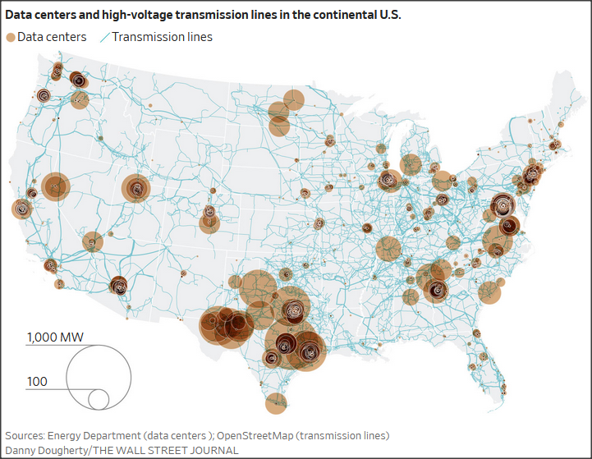
Current Data Centers
Source: Wall Street Journal

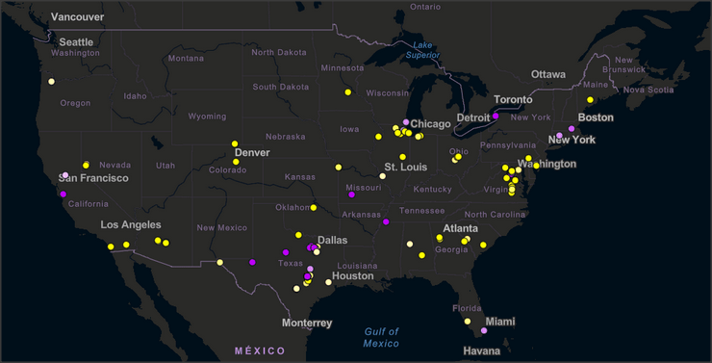
Data Centers Proposed & Under Construction, October 2024
Source: Hubexo Construction Wire

Recent Department of Energy projections see data center electricity demand rising from an estimated 176 TWh (4.4% of US electricity demand) in 2023, to between 325 TWh (6.7%) to 580 TWh (12.0%) by 2028. Separate estimates put cryptocurrency mining operations—also located predominantly in other states due to the same cost and permitting factors even though many of these companies are headquartered in California—at 70 TWh in 2023 and about 240 TWh by 2028.

California Cuts GHG Emissions by 21% Since 2000—But at What Cost?

Following the recent release of Air Resources Board’s 2023 GHG Inventory, the governor once again claimed victory for California’s climate programs, stating “While California’s emissions go down, its economy continues to expand.” In all, the 2023 inventory estimates the state has reduced its emissions by 21% since 2000, or the “equivalent to removing the annual emissions from 22.9 million cars.”

As usual, the announcement as with the Air Board materials again is silent on the costs being paid by households and employers to achieve these reductions. The governor in fact recently has gone so far as to claim that the recent extension of the state’s Cap & Trade fee is “a major victory for affordability” rather than what it really is: a carbon tax that increases the cost of energy consumed by households and employers only in this state. For example, the latest numbers indicate Cap & Trade accounts for 29 cents (6%) of every gallon of gasoline and is rising. Comparable increases also affect the cost of electricity, diesel, natural gas, and air travel through jet fuel, both directly and as these taxes percolate through the economy and affect the costs of other goods and services.

As a partial estimate of the additional costs related to the state’s emissions program, the following focuses on the primary direct energy purchases by households and employers. These are only partial estimates. They do not include items such as various measures—building code changes, climate based CEQA lawsuits, VMT fees, etc.—that affect both the availability and cost of housing, added costs to imported goods due to port regulations, economic effects from companies locating their more energy-cost sensitive operations to lower cost locations, and others.

The following assumptions were used in deriving these estimates:

- Rather than 2000, due to data availability and to ensure a more proper accounting, the analysis considers emission reductions since 2010, the year the state’s current climate change programs began under the AB 32 Early Action Items. Some of the current measures predate that point, including some Air Board fuel regulations, early iterations of the Renewable Portfolio Standard for electricity, early electric vehicle requirements, and various regulations under the Energy Commission and PUC, but the bulk of the state’s mandates have been imposed or made stricter since 2010. This period covered 77% of the emission reductions since 2000, or to use the Air Board’s favored metric, the equivalent of removing the annual emissions of 17.7 million cars.

- As a general measure, California costs are measured compared to the average for the rest of the US. There are many other factors that lie behind the increasing divergence between these costs, but in general they reflect a general state trend of increasing the spread rather than efforts to bring these costs more in line through a direct consideration of affordability. They also reflect the tendency of the state to pursue a never-ending spiral of raising costs even further to subsidize the most affected households rather than deal with the factors pushing costs up directly. This approach also reflects the de facto aggregate effect of state policies increasing energy costs in general to lower demand and consequently emissions. At the same time, by not using a comparison with the lowest cost states, this approach underestimates the costs that would otherwise result from using this “art of the possible” as the base.

- As taken from the Center’s data banks, costs are broken out by fuel type and where available, by end user and applied to annual consumption. The cost spread for gasoline is taken from the Center’s reported data for regular gasoline. Data sources include: Air Resources Board, California Department of Finance, California Department of Tax & Fee Administration, US Energy Information Administration, US Department of Transportation, GasBuddy.com, and Kelley Blue Book.

- Using the recently published final electricity data from US Energy Information Administration, costs are estimated for 2010 through 2024

The results are shown in the following table, expressed both as a total additional cost paid by households and employers and, to put these numbers into perspective, an equivalent amount per household. The table accounts for the increased costs to gasoline, diesel, natural gas, and electricity.

Estimated Cost Impact on Energy
Source: see text
 | Total ($b) | Per Household ($)
2010 | $15.2 | $1,206
2011 | $15.0 | $1,190
2012 | $17.1 | $1,351
2013 | $18.7 | $1,465
2014 | $20.0 | $1,555
2015 | $27.5 | $2,129
2016 | $24.9 | $1,908
2017 | $29.4 | $2,236
2018 | $33.3 | $2,513
2019 | $38.7 | $2,897
2020 | $36.5 | $2,711
2021 | $43.5 | $3,229
2022 | $53.5 | $3,923
2023 | $57.2 | $4,156
2024 | $62.1 | $4,477
Total | $492.6

As indicated, the estimated cost of California’s emission reductions to date are nearly a half trillion dollars in higher energy costs. Again to put this amount into the Air Board’s favored metric, while the emission reductions to date are equivalent to removing the annual emissions of 17.7 million (internal combustion engine) cars, the direct costs paid to achieve these reductions would have allowed Californians to buy 12.6 million (internal combustion and electric) cars and put them back on the roads.

Other claims in the recent press releases also only tell part of the story, notably:

“While California’s emissions go down, its economy continues to expand.”

Using a more recent period to show the cumulative effect of these policies (2019-2025:Q2), California’s economy as measured by Real GDP has grown at a rate roughly the same as the US as a whole, at 17.0% for California compared to 17.1% for the US.

California Real GDP, 2019-2025:Q2
Source: US Bureau of Economic Analysis
 | CA | US
Real GDP, Total | 17.0% | 17.1%
Above ex Information & Professional, Scientific & Technical Services | 6.0% | 11.6%
Above ex Government and Healthcare & Social Services | 3.3% | 11.3%

As we have indicated previously, however, California’s GDP and its state revenue base are dependent to a far greater extent on its status as a center for High Tech. These businesses in turn, at least the portion that operates within California, are also far less affected by the state’s climate change regulations compared to its other traditional industries. Putting aside the two High Tech containing industries (Information and Professional, Scientific & Technical Services), the rest of the state’s economy grew only 6.0%, or roughly half of the 11.6% gain for the US as a whole.

But there’s more. Rather than growing, California’s jobs have essentially been stagnant over the past two years. What job growth there has been has come only from Government and government-supported Healthcare & Social Services. All other private industries as a whole instead have cut the number of jobs in the state. Putting these two industries aside as well, the bulk of the state’s economy that is the most affected by the regulations was essentially stagnant, growing only 3.3% (0.7% annually) compared to 11.3% for the US overall.

California’s economy has grown in spite of its regulations because its economy depends to an extraordinary extent on businesses that are not affected by those regulations. Those that are instead are now expanding elsewhere in the US. As California’s emissions have gone down, so has the contribution from the broader swath of industries that historically have supported middle class wage jobs in our state.

“Over the total period since 2000, greenhouse gas emissions in California went down by 21%”

The correct statement is that measured emissions went down by this much, accounting for emissions generated in the state or through imported electricity consumed in the state. The High Tech industry behind the state’s growth in this period, however, generated relatively few emissions within the state, but instead exported that portion of their footprint to other states and other regions.

Apple, for example, generates substantial emissions in its manufacturing and product transportation arrangements, but those activities are largely in other countries and in other countries largely dependent on coal.

High Tech in general is shifting quickly to a focus on AI, a move that is generating a sharp spike in electricity demand for new data centers. As discussed above, those centers are largely bypassing California due to its high energy costs, reliability issues, and lengthy permit processes. Those jobs and local tax base instead are moving to other states, substantially increasing emissions in those locations both due to overall energy demand as well as the relatively higher GHG profiles of local electricity generation.

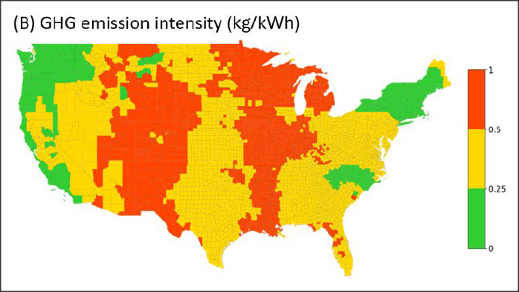
GHG Emission Intensity of Electricity Use by County
Source: US Department of Energy

The claim that the state is reducing emissions while continuing to grow its economy is based solely on measuring only what happens within the state. As the state’s economy grows, so are emissions. California is able to claim victory on this score only because it is exporting the impacts of its growth to other locations.

Inflation
3.3% |  |  | For the 12 months ending August, the California CPI rose 3.3%, up from 3.1% for the year ending July. In the same period, the US CPI went to 2.9% in August from 2.7% in July. Using the same Department of Finance weighting formula, Food at Home (groceries) rose 3.8% in California compared to 2.7% for the US. Food Away from Home (restaurants and takeout) rose 4.2% compared to the US at 3.9%.
Increase Since August 2024
California vs. Rest of US Fuel Price Gap at 57.8% Premium
$1.70 |  |  | The October average price per gallon of regular gasoline in California eased 1 cent from September to $4.64. The California regulatory and tax premium above the average for the US other than California ($2.94) rose to $1.70, a 57.8% difference.
Price Per Gallon
Above Other States
(CA Average)
1st |  |  | In October, California had the highest gasoline price among the contiguous states and DC. Californians paid $2.06 a gallon more than consumers in Oklahoma, the state with the lowest price.
Ranked by
price
California Gasoline Taxes & Fees
$1.50 |  |  | As we have discussed in prior reports, in the absence of current Energy Commission data, we have begun our own estimates using the Commission factors and the new OPIS data. In October, $1.50 (32.3%) of the price of a gallon of regular gasoline was paid to cover state, local, and federal taxes and fees.
Total Taxes & Fees per Gallon of Gasoline
California Carbon Taxes: LCFS and Cap & Trade
Per Gallon Carbon Taxes, October 2025
Source: OPIS adjusted to include sales tax
 | LCFS | Cap & Trade |  | Total
Gasoline | $0.15 | $0.29 |  | $0.44
Diesel | $0.18 | $0.36 |  | $0.54
In October, total LCFS charges incorporated in the price Californians pay for fuel was unchanged for gasoline and rose 1 cent for diesel, while the Cap & Trade component rose 2 cents for each fuel. The costs shown in the table are for the penultimate month-to-date numbers from the OPIS Carbon Market Report, adjusted to incorporate state and local sales tax to account for the full additional costs imposed by these regulatory fees on fuel buyers. Certain Data or Information Provided By: Oil Price Information Service, LLC. Distribution of OPIS data without permission from OPIS is prohibited.
Combining the OPIS data (without the sales tax component) with the previous Energy Commission estimates, Cap & Trade costs are now showing a sustained rise following the program’s extension. LCFS costs had been easing before June as the result of data corrections discussed in last month’s report, but sharply reversed course as the new regulations took effect in July. Note that both charts include both the Cap & Trade components charged at the rack and levied on production from the OPIS data, and only the rack component in the Energy Commission data.

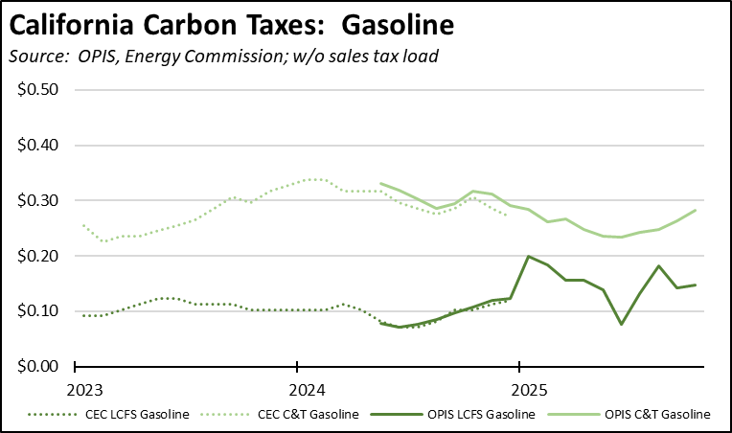

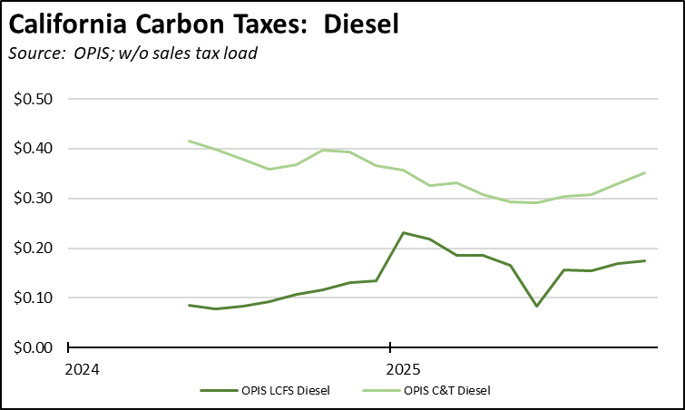

The cost effect of the amended LCFS regulations continues to be masked by the high level of banked credits. Overall, credit prices have been largely level, showing only a marginal change since the end of July on a 4-week moving average basis. This price moderation and the resulting stable impact on fuel prices stem from the continued run-up in banked credits, which reached their highest level yet of 43.0 million in the 2nd quarter just prior to the effective date of the amended regulations. As the increasingly stricter standards under the amended regulations begin to eat away at this buffer, credit prices and the consequent costs to households and employers will begin trending back up towards historical levels.

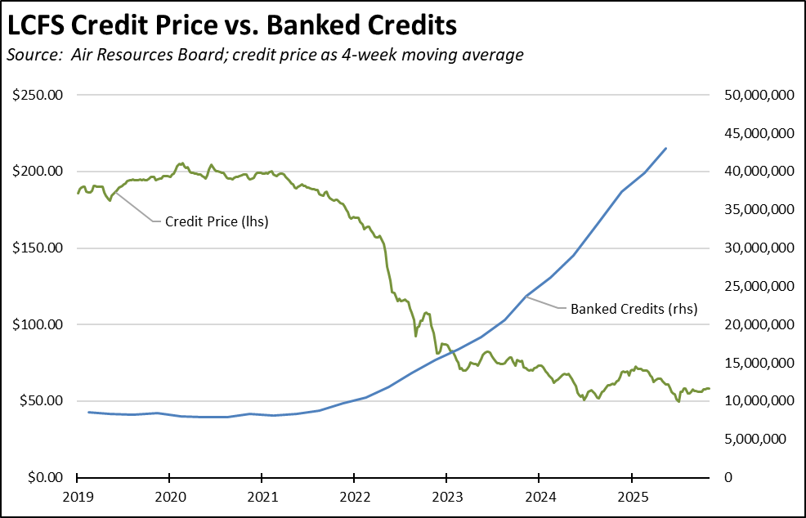
California vs. Rest of US Diesel Price
$1.58 |  |  | The October average price per gallon of diesel in California eased 2 cents from September to $5.14. The California regulatory and tax premium above the average for the US other than California ($3.55) rose to $1.58, a 44.5% difference.
Price Per Gallon
Above Other States
(CA Average)
1st |  |  | In October, California had the highest diesel price among the contiguous states and DC.
Ranked by
price
Range Between Highest and Lowest Prices by Region
$1.91 |  |  | The cost premium above the US (other than California) average price for regular gasoline ranged from $1.58 in the Central Valley Region (average October price of $4.52), to $1.91 in Central Sierra Region (average October price of $4.85).
Price per Gallon above Other States (Central Sierra Region)
Highest/Lowest Fuel Prices by Legislative District:
October 2025: Average Price ($ per gallon) of Regular Gasoline
 |  |  | Highest
CD02 Huffman (D) |  |  | $4.87
CD30 Friedman (D) |  |  | $4.84
CD50 Peters (D) |  |  | $4.84
CD03 Kiley (R) |  |  | $4.80
CD49 Levin (D) |  |  | $4.80
SD24 Allen (D) |  |  | $4.83
SD02 McGuire (D) |  |  | $4.81
SD38 Blakespear (D) |  |  | $4.80
SD39 Weber (D) |  |  | $4.80
SD17 Laird (D) |  |  | $4.77
AD02 Rogers (D) |  |  | $4.91
AD51 Zbur (D) |  |  | $4.90
AD77 Boerner (D) |  |  | $4.89
AD30 Addis (D) |  |  | $4.87
AD78 Ward (D) |  |  | $4.85
 |  |  | Lowest
CD21 Costa (D) |  |  | $4.51
CD06 Bera (D) |  |  | $4.51
CD22 Valadao (R) |  |  | $4.48
CD01 LaMalfa (R) |  |  | $4.46
CD09 Harder (D) |  |  | $4.46
SD08 Ashby (D) |  |  | $4.53
SD29 Reyes (D) |  |  | $4.53
SD05 McNerney (D) |  |  | $4.52
SD01 Dahle (R) |  |  | $4.51
SD16 Hurtado (D) |  |  | $4.45
AD33 Macedo (R) |  |  | $4.47
AD35 Bains (D) |  |  | $4.46
AD22 Alanis (R) |  |  | $4.41
AD13 Ransom (D) |  |  | $4.40
AD03 Gallagher (R) |  |  | $4.39
California Residential Electricity Price
98.1% |  |  | California average Residential Price for the 12 months ended August 2025 was 31.94 cents/kWh, 98.1% higher than the US average of 16.12 cents/kWh for all states other than California. California's residential prices were the highest among the contiguous states and DC.
Above Average for Rest of US
Highest/Lowest Electricity Rates by Legislative District:
Average Residential Electricity Rate (cents/kWh), 2024
 | Highest
CD52 Vargas (D) | 43.63
CD50 Peters (D) | 43.63
CD51 Jacobs (D) | 43.63
CD49 Levin (D) | 43.32
CD48 Issa (R) | 39.66
SD39 Weber (D) | 43.63
SD40 Jones (R) | 43.52
SD38 Blakespear (D) | 41.90
SD17 Laird (D) | 39.62
SD11 Wiener (D) | 39.62
AD76 Patel (D) | 43.63
AD77 Boerner (D) | 43.63
AD80 Alvarez (D) | 43.63
AD78 Ward (D) | 43.63
AD79 Sharp-Collins (D) | 43.63
 | Lowest
CD32 Sherman (D) | 23.98
CD37 Kamlager (D) | 23.77
CD29 Rivas (D) | 23.63
CD07 Matsui (D) | 22.32
CD06 Bera (D) | 21.40
SD26 Durazo (D) | 24.97
SD28 Smallwood-Cuevas (D) | 23.94
SD06 Niello (R) | 23.71
SD20 Menjivar (D) | 23.24
SD08 Ashby (D) | 21.17
AD43 Rodriguez (D) | 23.72
AD22 Alanis (R) | 22.08
AD36 Gonzalez (R) | 21.70
AD10 Nguyen (D) | 19.60
AD07 Hoover (R) | 19.12

California Residential Electric Bill
14th |  |  | For the 12 months ended August 2025, the average annual Residential electricity bill in California was $1,881, or 89.2% higher ($887) than the comparable bill in 2010 (the year the AB 32 implementation began with the Early Action items). In this same period, the average US (less CA) electricity bill for all the other states grew only 30.0% ($409).  In 2010, California had the 9th lowest residential electricity bill among the contiguous states and DC. In the latest data, it had the 14th highest.
Ranked by Cost
 |  |  | Residential bills, however, vary widely by region. Transforming the 2022 data recently released by the Energy Commission, estimated annual household usage is as much as 82% higher in the interior regions compared to the milder climate coastal areas, and substantially higher when comparing across counties.
$13.2b |  |  | For the 12 months ended August 2025, California's higher electricity prices translated into Residential ratepayers paying $13.2 billion more than the average ratepayers elsewhere in the US using the same amount of energy. Compared to the lowest cost state, California households paid $17.1 billion more.
Above Average for Rest of US
California Commercial Electricity Price
110.9% |  |  | California average Commercial Price for the 12 months ended August 2025 was 25.67 cents/kWh, 110.9% higher than the US average of 12.17 cents/kWh for all states other than California. California's commercial prices were the highest among the contiguous states and DC.
Above Average for Rest of US
California Industrial Electricity Price
174.0% |  |  | California average Industrial Price for the 12 months ended August 2025 was 21.54 cents/kWh, 174.0% higher than the US average of 7.86 cents/kWh for all states other than California. California's industrial prices were the highest among the contiguous states and DC.
Above Average for Rest of US
$21.3b |  |  | For the 12 months ended August 2025, California's higher electricity prices translated into Commercial & Industrial ratepayers paying $21.3 billion more than ratepayers elsewhere in the US using the same amount of energy. Compared to the lowest rate states, Commercial & Industrial ratepayers paid $27.7 billion more.
Above Average for Rest of US
EV Charging Rates

11th | California’s high electricity rates also affect a number of other public policies. Using the average public charging rates from AAA as of November 7, California tied with 3 other states for the 11th highest cost among the contiguous states. At 40.5 cents per kWh, the average California rate was 8.9% higher than the overall US average. States ranged from 26.1 cents in Kansas to 53.6 cents in West Virginia.  The effect on the state’s goals for expanding electric vehicle market share is shown in table using mileage information from the US Department of Energy, the highest selling electric (Tesla Model Y) and gasoline (Toyota RAV4, which comes in both gasoline and hybrid configurations) models in the 3rd quarter, and the average gasoline prices in October. Electric vehicles show an operating cost advantage only because of state policies that keep gasoline prices elevated well above the other states. This advantage disappears when prices prevailing in the rest of the country are taken into account.  Note that the table addresses only one cost component for comparing these vehicle classes. A number of other factors can affect the results including: (1) a number of studies demonstrate the official mileage numbers for electric vehicles are inflated by about 12%; (2) other cost differences exist for these two classes including maintenance and repair, insurance, purchase prices, and resale value; and (3) operating costs will be lower for home charging, although expansion of electric market share has been hindered by renters in particular having to rely on public charging.
  Fueling Cost Comparison, Public Charging vs. Gasoline
  Source: see text
   | Model Y | RAV4 | Cost/100 miles
  Electricity, California | $0.405 |  | $12.15
  Gasoline, California |  | $4.642 | $16.01
  Electricity, Other States | $0.359 |  | $10.77
  Gasoline, Other States |  | $2.941 | $10.14
Public Charging Rank Among Contiguous States

California Natural Gas Prices
Average prices ($ per thousand cubic feet; 12-month moving average) for the 12 months ended August 2025 and changes from the previous 12-month period for each end user:
 |  |  | Residential |  |  | Commercial | Industrial
CA, August 2025 |  |  | $21.07 |  |  | $15.49 | $12.32
CA, August 2024 |  |  | $19.52 |  |  | $14.12 | $11.58
Change |  |  | 7.9% |  |  | 9.7% | 6.4%
Rest of US, August 2025 |  |  | $14.38 |  |  | $10.22 | $4.18
Rest of US, August 2024 |  |  | $14.55 |  |  | $9.78 | $3.38
Change |  |  | -1.2% |  |  | 4.5% | 23.7%
CA premium over Rest of US, August 2025 |  |  | 46.5% |  |  | 51.6% | 194.7%
CA premium over Rest of US, August 2024 |  |  | 34.2% |  |  | 44.4% | 242.6%

